July 28, 2021

For Immediate Release

Contact: Marcy Marshall
Media Relations, PeaceHealth
732-762-2354 (cell)
mmarshall@peacehealth.org

PeaceHealth Oregon announces
new medical and surgical chief medical officers

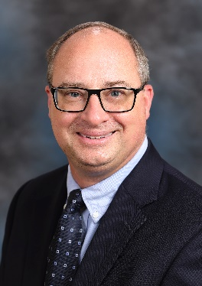
SPRINGFIELD, Ore. – We are pleased to share that James McGovern, MD, PeaceHealth Oregon network’s vice president of medical affairs, has been named medical chief medical officer (CMO) for the network and Melissa Edwards, MD, system medical director of PeaceHealth’s Women’s Health service line and CMO for Women’s Care, has been named surgical CMO for the network.

Dr. McGovern stepped into the interim CMO role on Jan. 1, 2021 following the retirement of PeaceHealth Oregon Network CMO and System Chief Clinical Officer Andrea Halliday, MD.

Dr. McGovern is a seasoned physician leader with training and experience in Lean process improvement. He previously served for 14 years in various leadership roles, most recently as system vice president of medical affairs, at ThedaCare in Wisconsin. Dr. McGovern graduated from the Medical College of Wisconsin.

A board-certified gynecologist, Dr. Edwards has a breadth and depth of experience in practice management, EMR implementation, accreditation, peer review, quality and safety, care transformation and clinical integration. Dr. Edwards has served in her chief medical officer role at Women’s Care since 2011 and also serves on the PeaceHealth Sacred Heart Community Health Board and is chair of Sacred Heart Medical Center at RiverBend’s GYN department. She earned her medical degree from Oregon Health & Science University in Portland.

In their CMO roles, Drs. McGovern and Edwards will lead quality, patient safety and patient experience initiatives in collaboration with the medical staff, network leaders and other key stakeholders.

About PeaceHealth: PeaceHealth, based in Vancouver, Wash., is a not-for-profit Catholic health system offering care to communities in Washington, Oregon and Alaska. PeaceHealth has more than 15,000 caregivers, a group practice with more than 1,200 providers and 10 medical centers serving both urban and rural communities throughout the Northwest. In 1890, the Sisters of St. Joseph of Peace founded what has become PeaceHealth. The Sisters shared expertise and transferred wisdom from one medical center to another, always finding the best way to serve the unmet need for healthcare in their communities. Today, PeaceHealth is the legacy of the founding Sisters and continues with a spirit of respect, stewardship, collaboration and social justice in fulfilling its Mission. Visit us online at peacehealth.org.

###

