NEWS RELEASE
For Immediate Release
Media Contact:
Megan Brezovar
megan.br@green-hill.org
541.689.1503 ext 134
Cold Weather Safety Tips for Pets
Safety tips to keep in mind with upcoming inclement weather conditions

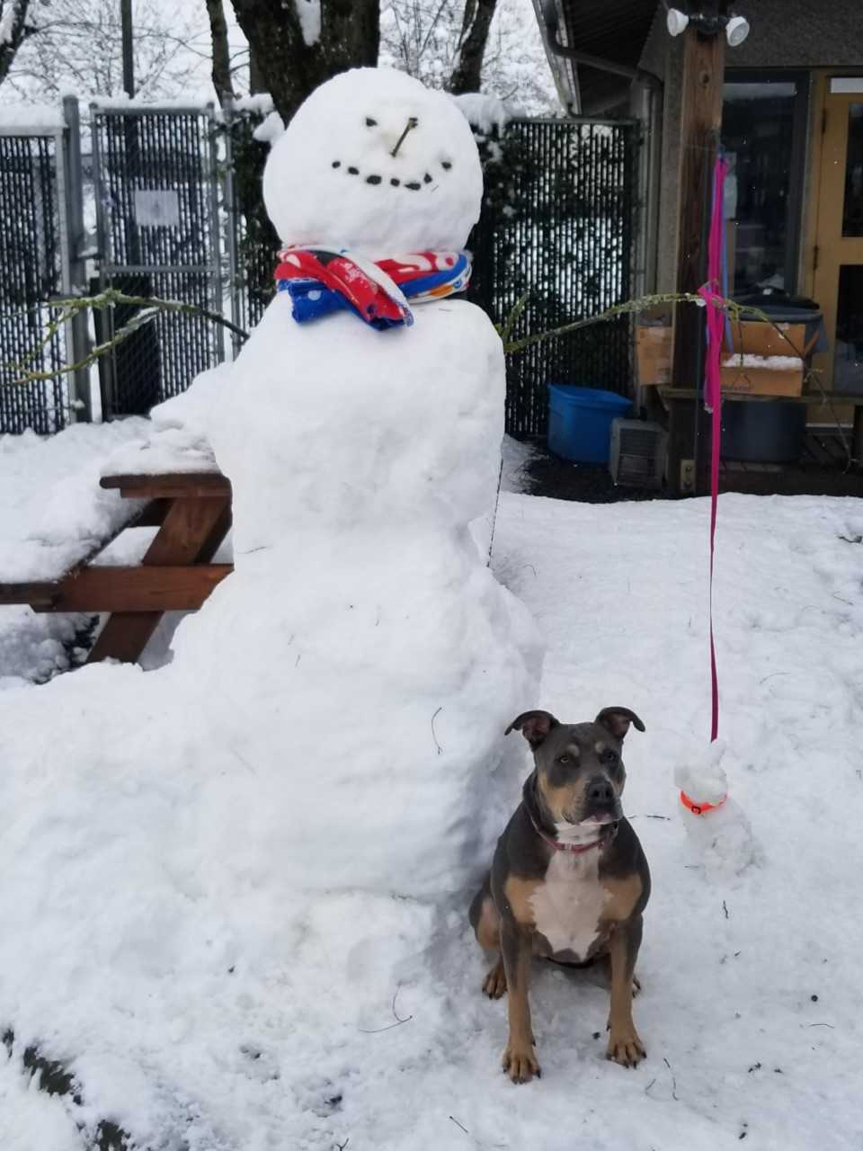

EUGENE, OREGON – (December 23, 2021) – With the weather getting colder, windier, and potentially snowy, Greenhill Humane Society wants to encourage pet families to take extra precaution before heading out on adventures. Dry, cold air, chilly rain, sleet, and snow can cause chapped paws, itchy skin and other discomforts to your pet. Follow the tips below to ensure your pets are enjoying their outside adventures this winter:
- Remember, if it’s too cold for you, it’s cold for your pet, so keep your animals inside. Pets who are unaccustomed to being out in the cold can freeze, become disoriented, lost, stolen, injured or harmed.
- Towel dry your pet as soon as they come inside, paying special attention to their feet and in-between the toes. Remove any snow from between their foot pads.
- Never shave your dog down to the skin in winter, as a longer coat will provide more warmth. If your dog is short-haired, consider getting them a coat or sweater.
- After each walk, wash and dry your pet’s feet and stomach to remove ice, and check for cracks in paw pads or redness between the toes. Ice melt products can be irritating to pet’s feet and should be washed off. Use pet-friendly ice melts whenever possible.
- Booties can provide coverage and warmth, and can also prevent ice and salt from getting lodged between bare toes and causing irritation.
- Pets burn extra energy by trying to stay warm in wintertime. Pets who spend a lot of time outdoors may need to be fed more during the cold weather months.
- Make sure your companion animal has a warm place to sleep, off the floor and away from all drafts. A cozy dog or cat bed with a warm blanket or pillow is perfect.
- If your pet is shivering and refuses to play, the animal is too cold and should come inside.
- Antifreeze is lethal poisons for dogs and cats. Be sure to thoroughly clean up any spills from your vehicle, and consider using products that contain propylene glycol rather than ethylene glycol.
- Car motors are of particular danger to cats who sleep outside. Cats seek the warmth of car motors, and they can be severely injured or killed when caught in the fan belt of a car's engine. Make it a habit to knock on the hood of the car or honk your horn before starting your car.
“The Willamette valley will be experiencing severe winter weather so it is important that we make sure our pets are warm and safe in the extreme cold and snow,” said Megan Brezovar, Greenhill’s Engagement & Humane Education Manager. “One easy way to make sure your pets feel warm and comfortable is to limit their time in the harsh elements and make sure their bodies and paws are dry after romping in the snow. Giving outside cats indoor access will help protect them from freezing temperatures.”
To learn more about Greenhill Humane Society or tips on keeping your pets safe in inclement weather, visit www.green-hill.org.
###
About Greenhill Humane Society
Greenhill Humane Society has been caring for animals in Lane County since 1944. It is a private, non-profit organization that relies on charitable donations. Greenhill is located at 88530 Green Hill Road in Eugene. We envision a world in which all animals are treated with compassion and respect. To learn more visit www.green-hill.org or follow at Facebook, Instagram, and Twitter.

