New Year New Home for Yellow Emperor
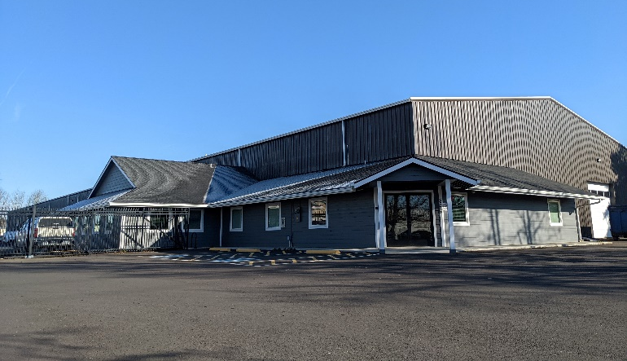
Eugene, OR - In the first weeks of 2022, Yellow Emperor moved its warehouse and administrative team to a new facility. As the year progresses and the new production area is completed, the production team will join the rest in the new space. The new building, a mile away from the current production facility, is almost 50,000 square feet with plans to expand over the next 3 years to 100,000.
From the President, Joe Stipek, “I couldn’t be prouder of the team here at Yellow – without them and their hard work we wouldn’t be able to make such a move happen. They all care about what they do and desire to see our business continue to grow and change. I remain humbled by their dedication and am excited to see our continued growth into the future.”
Yellow Emperor is a liquid contract manufacturer of dietary supplements, food, and personal care products for people and animals that has been in business for over 40 years. The business moved to Eugene, OR in the early 1980s and within the past 10 years has seen exponential growth, warranting a new space for production.

