Media Contact
Broussard Communications
Melissa Broussard, 503-702-4620
Melissa@broussardcommunications.com

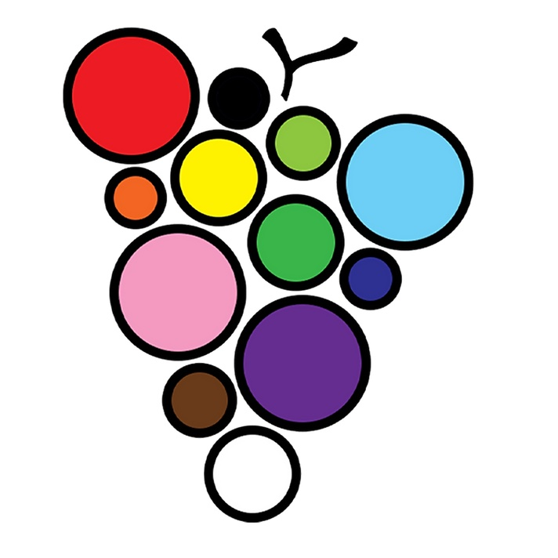
CELEBRATE WINE COUNTRY PRIDE THIS JUNE
Oregon nonprofit Wine Country Pride (WCP) to bring various Pride celebrations to the rural Willamette Valley wine growing regions this June in support of the local LGBTQIA+ community

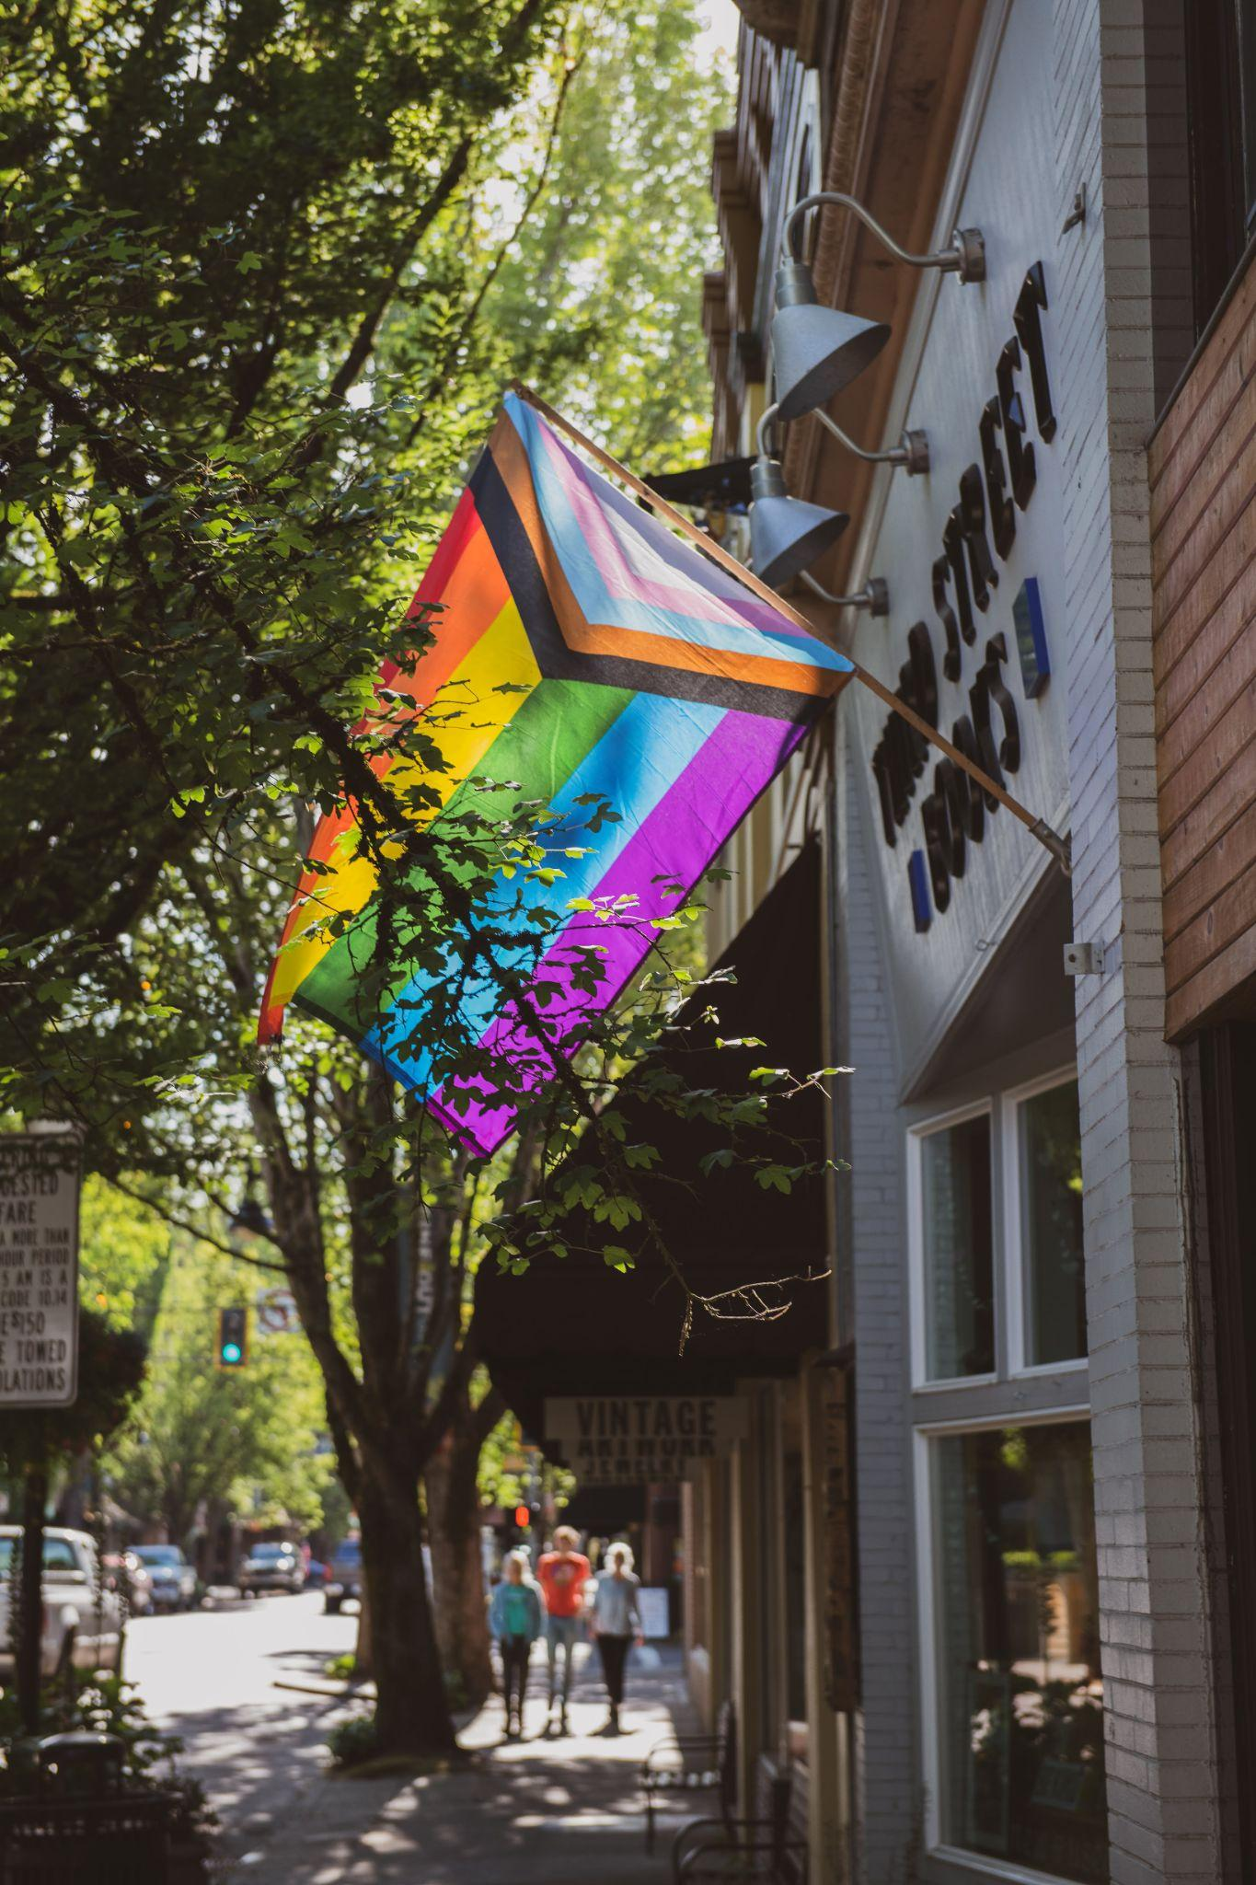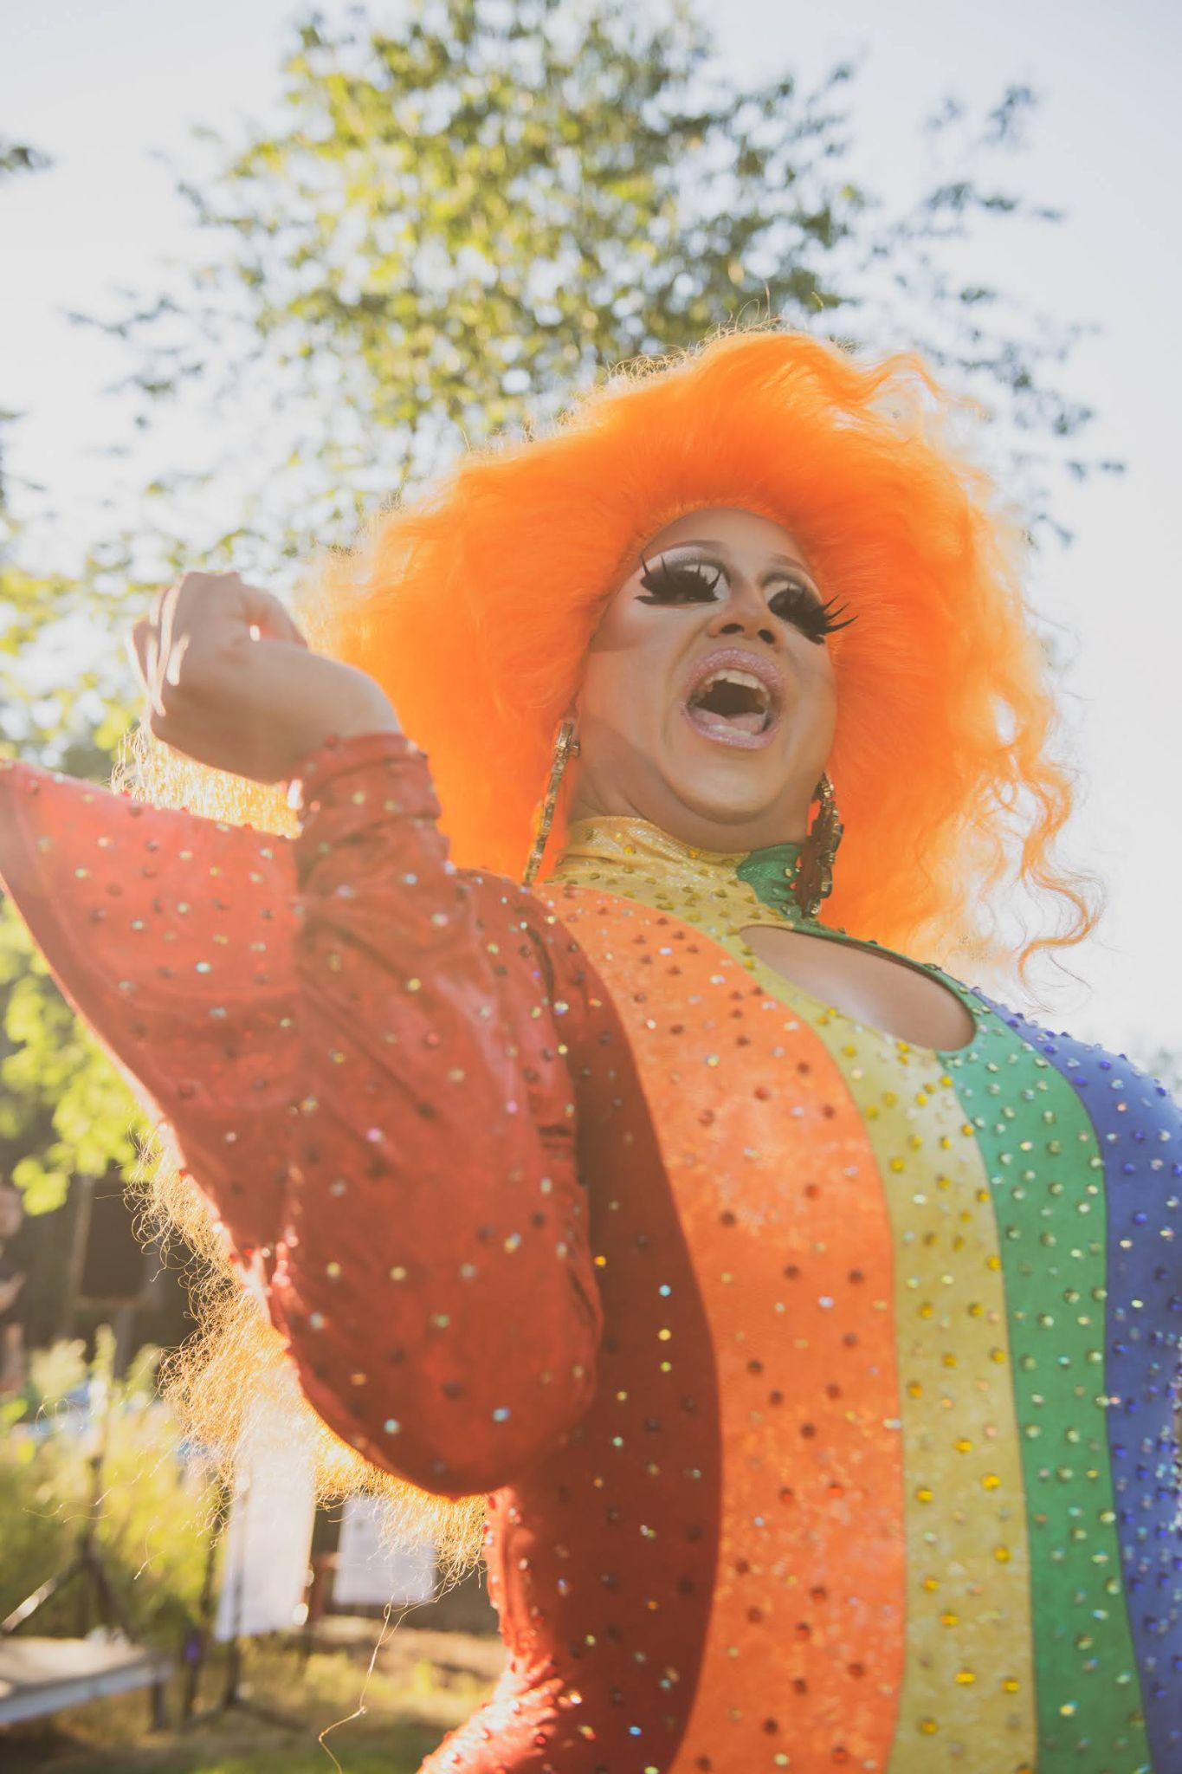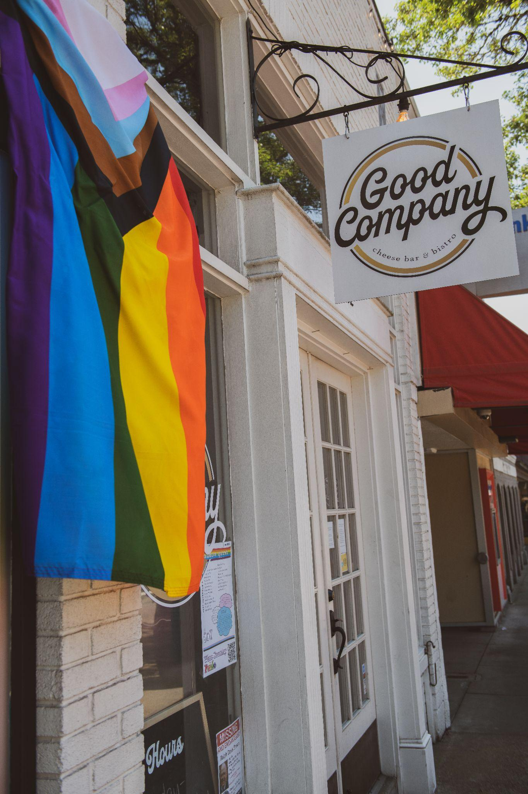
Photo credit - Zach Alan Photography

PORTLAND, Ore. (May 25, 2022) – Wine Country Pride, a nonprofit dedicated to creating community and support systems for rural Oregon’s LGBTQIA+ community, will celebrate Pride Month with various events in Oregon Wine Country this June, including the world’s first Queer Wine Fest and the area’s first ever large-scale Pride event: the 2022 Street Fair.

Events will raise money for Wine Country Pride’s scholarship program in partnership with PFLAG Newberg. Together they provide college or vocational school scholarships to the area’s LGBTQIA+ high school seniors, awarding seven scholarships last year alone.

Funds will also go toward supporting local businesses and organizations that advocate for the LGBTQIA+ community, as well as toward the creation of programs and events – such as queer meet ups and library book inclusivity initiatives – that aim to connect people through education, visibility, and fun.

Wine Country Pride kicks off June 1st with Rainbow Quest, where 53 local coffee shops, wineries, restaurants, bars, and retailers in Yamhill County will offer Pride-inspired drinks, food, and products throughout June to raise money for WCP and to show their love for the LGBTQIA+ community.

It continues with the following events:

- Friday, June 3rd at 6:30pm - Pollinate Dinner in the flower gardens of Pollinate Nursery and catered by Red Hills Market. SOLD OUT.
- Sunday, June 12th at 11am - Lez Brunch at Remy Wines featuring Queer trivia, wine, and brunch prepared by Remy Drabkin, founder of Remy Wines and the first queer Mayor of McMinnville. Tickets are available for $50 per person, 21+. A portion of ticket costs support WCP.
- Friday, June 17th at 5:30pm - Yoga for Wine Country Pride at Boho Yoga. Move in community through sweet flows that encourage deep Self liberation to benefit WCP. $25, open to all ages.
- Friday, June 24th from 6-9pm - World’s first Queer Wine Fest, which will celebrate and bring together 18 queer-owned, queer-made, and queer-grown wineries from CA, WA, and OR outdoors at the Remy Wines Tasting Room. Tickets are $125 if purchased from Eventbrite before June 1 and $145 after. Ticket prices cover wine, food, entertainment and a donation to Wine Country Pride. 21+.
- Saturday, June 25th from 12-7pm - First ever large-scale Pride event in rural Oregon with over 1,000 people expected to attend. The 2022 Street Fair will feature speakers, performers, puppy parades, speed dating, food, drink, and vendors spread across Alpine Ave in McMinnville. The Street Fair is free, open to all ages, and includes bilingual programming and all-day ASL interpretation.
- Saturday, June 25th at 9pm - Pride Drag-Stravaganza featuring a Drag Show to eclipse all Drag Shows, burlesque, and a speech by Mayor Remy Drabkin. At Mac Market 18+, tickets will be available soon. There will be bilingual programming and ASL interpretation.
- Sunday, June 26th at 8:30am - Morning Yoga in Nature at Durant Vineyards with instructor Rose Schneider of Boho Yoga. This class is an all-level* morning flow practice. 100% of the proceeds are donated to Wine Country Pride.
- Sunday, June 26th at 1:30pm - Newberg 3rd Annual PFLAG Family Car Parade + Picnic to show support and solidarity with LGBTQ+ neighbors. Free and open to all ages, simply register your car ahead of time if you plan on driving the parade route.
- Sunday, June 26th at 12pm - Dragstravaganza 2022 at Youngberg Hill with brunch and drag show featuring Oregon's very own Miss Gay Oregon 2021, Nicole Onoscopy, and her fellow Queens.

Further event details and tickets are available through Wine Country Pride.

Businesses who would like to show support for Wine Country Pride and members of the LGBTQIA+ community can request free Progress Pride Flags as part of the WCP Flag Campaign. Flying the flag shows members of the LGBTQIA+ community that they are safe, welcome, and will be treated with respect when patronizing the business. Individuals looking to fly a flag can purchase one at Pollinate Flowers (Newberg),​ Sustainable Rituals inside of Mac Market (McMinnville), and Remy Wines (Dayton).

About Wine Country Pride:
Wine Country Pride is a 100% volunteer run organization founded in 2020 by a small group of like-minded local friends and business owners: Remy Drabkin, Kristen Stoller, KC Marold, Sara Linnertz, Zach Goff, John Peterson and Jacob Sembler. Realizing there was simply not enough representation of the LGBTQIA+ community in the rural Willamette Valley wine growing regions, they started Wine Country Pride to celebrate and support the rural queer community year-round by connecting all people through education, visibility, economic activity, and fun. Since their first event, WCP has raised over $30,000. These funds provide scholarships to LGBTQIA+ youth and support local organizations that advocate for the LGBTQIA+ community.

