Oct. 11, 2022

For Immediate Release

Contact: Sherri Buri McDonald
Media Relations, PeaceHealth Oregon
541-520-8219 or SBuriMcDonald@peacehealth.org

PeaceHealth completes modernization project
at Sacred Heart Medical Center, University District campus

EUGENE, Ore. –The PeaceHealth Sacred Heart Medical Center, University District campus has undergone a major transformation over the past 1 ½ years.
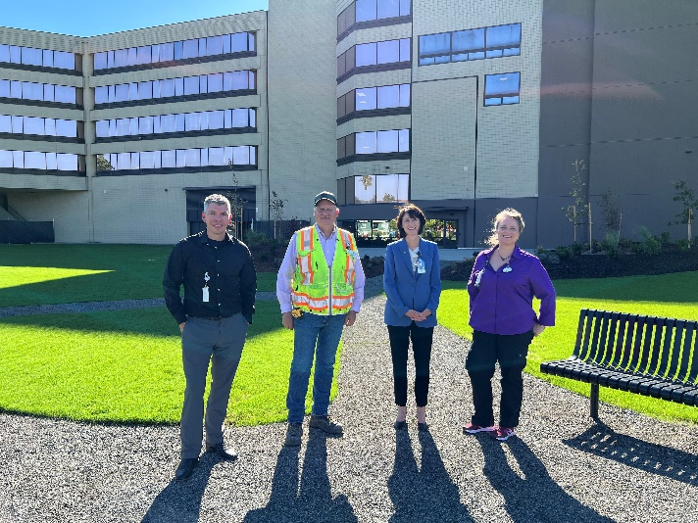
Crews with excavators arrived in April 2021, and they carefully removed four vacant buildings to the east of the main hospital tower. Those buildings included the former in-patient behavioral health Johnson Unit and the last wing of the former Sacred Heart General Hospital. Now, in their place, is a 100,000-square foot lawn, roughly the size of 1 ¾ football fields.
Workers also revitalized the hospital lobby—completing a new Chapel, Heartfelt Gifts shop and dining area— to better serve our patients, visitors and caregivers.
“This project went very smoothly,” says Alicia Beymer, chief administrative officer of PeaceHealth’s University District campus and Cottage Grove Community Medical Center. “We want to thank Turner Construction Co. and their team of contractors. They worked closely with our clinical team—always putting the care for our patients and caregivers front and center.”
Here are a few statistics that illustrate the scope of this project:
Over 80,843: Total hours worked by crews

225: Tradespeople (demolition, construction, landscaping, etc.)

14,700: Tons of material removed during demolition

77: Percent of materials removed that were recycled

9,235: Tons of concrete recycled

2,179: Tons of metals recycled

78,000: Tons of engineered backfill for basements of removed buildings

3,700: Tons of topsoil to create the lawn

100,000: Square footage of lawn

2,500: Square footage of patio

For a quick glimpse of the entire project—start to finish—view this time-lapse video, which was captured from a rooftop camera on the south side of the PeaceHealth Sacred Heart Medical Center, University District campus.

About PeaceHealth: PeaceHealth, based in Vancouver, Wash., is a not-for-profit Catholic health system offering care to communities in Washington, Oregon and Alaska. PeaceHealth has approximately 16,000 caregivers, a group practice with more than 900 providers and 10 medical centers serving both urban and rural communities throughout the Northwest. In 1890, the Sisters of St. Joseph of Peace founded what has become PeaceHealth. The Sisters shared expertise and transferred wisdom from one medical center to another, always finding the best way to serve the unmet need for healthcare in their communities. Today, PeaceHealth is the legacy of the founding Sisters and continues with a spirit of respect, stewardship, collaboration and social justice in fulfilling its Mission. Visit us online at peacehealth.org.

###

