Contact
Kristen Salladay
American Cancer Society
541.517.8939 | Kristen.Salladay@Cancer.org

FOR IMMEDIATE RELEASE

Marcus Mariota joins American Cancer Society
as Real Men Wear Pink Ambassador in Lane County
Marcus Mariota and Motiv8 Foundation join thirteen other local men to raise breast cancer awareness and funds

EUGENE, OR – Oct. 3, 2022 – Duck alumnus Marcus Mariota has joined the American Cancer Society’s Real Men Wear Pink (RMWP) of Lane County campaign as a 2022 Ambassador.

“I’m participating in Real Men Wear Pink of Lane County in honor of my Auntie. As a breast cancer survivor and Army veteran, she inspires me to give back to others. As an ambassador for the American Cancer Society, I’m looking forward to creating awareness and making a difference in the fight against breast cancer,” said 2022 RMWP Ambassador, Marcus Mariota.
Mariota joins thirteen other local male leaders in supporting the RMWP campaign, four of whom are also new to the campaign: Stephen Baron (Willamette Valley Cancer Institute), David Dowling (Grain Millers), and Demond Hawkins (Trillium), and Trevor Foster ( Kendall Auto Group). The campaign plays a critical role as more than 2,700 men will be diagnosed with breast cancer in 2022 as well as more than 287,000 of their daughters, wives, mothers, sisters and friends.

The Real Men Wear Pink campaign was designed to engage more male community leaders and influencers in the American Cancer Society’s mission to eliminate breast cancer. Community leaders around the nation use the power of wearing pink to draw attention to the cause, in addition to raising funds and awareness through events and social media for the American Cancer Society’s breast cancer initiatives.

Real Men Wear Pink of Lane County raised more than $250,000 in 2021. The Lane County campaign was ranked sixth in the nation, with the top fundraiser, Robert Weeks with K.P.D. Insurance surpassing $40,000 in fundraising.
For the past six years, a group of Lane County men have participated in the American Cancer Society's Real Men Wear Pink campaign. Each member encourages the community to donate towards their individual campaigns. This year’s full list of ambassadors includes: Brian Alfano (OCCU), Stephen Baron (WVCI), Allan Benavides (Eugene Emeralds), Dallas Boggs (Eugene Police Commission), James Conners (Country Financial), David Dowling (Grain Millers), Demond Hawkins (Trillium Community Health Plan), Dominick Hicks (Anheuser Busch), Skeet Hise (Skeet Hise Tree Management), Matt Kendall (Keller Williams), Marcus Mariota (Motiv8 Foundation), Patrick Olsen (Patrick Olsen Auto Repair), and Joel Smith (Jordan & Williams, LLC), Trevor Foster (General Manager Kendall Chevy).
As of Oct. 3, the Real Men Wear Pink of Lane County has raised over $20,000. If you're interested in helping them fight against breast cancer, visit www.realmenwearpinkacs.org/LaneCoOR.

“These Real Men are real leaders,” said Laura Brown, RMWP co-chair. “Each ambassador has chosen to step up – many for multiple years in a row - to let the community know they are committed to making a difference. Through their advocacy, awareness building and funds raised, we’re able to help the society and save lives from breast cancer.”

For more information about Real Men Wear Pink visit realmenwearpinkacs.org/lanecoor or call 1-800-227-2345.

About the American Cancer Society
The American Cancer Society is on a mission to free the world from cancer. We invest in lifesaving research, provide 24/7 information and support, and work to ensure that individuals in every community have access to cancer prevention, detection, and treatment. For more information, visit cancer.org.

# # #

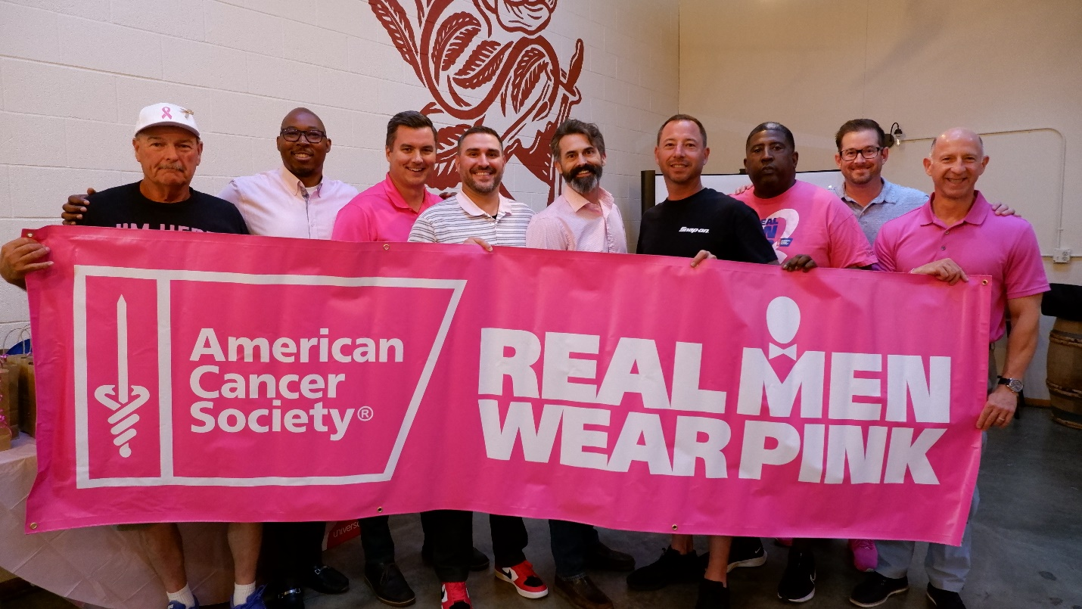
1 - Real Men Wear Pink of Lane County ambassadors at the 2022 kickoff event. Pictured left to right: Skeet Hise, Demond Hawkins, James Conners, Brian Alfano, Joel Smith, Patrick Olsen, Dallas Boggs, Matt Kendall and Stephen Baron.
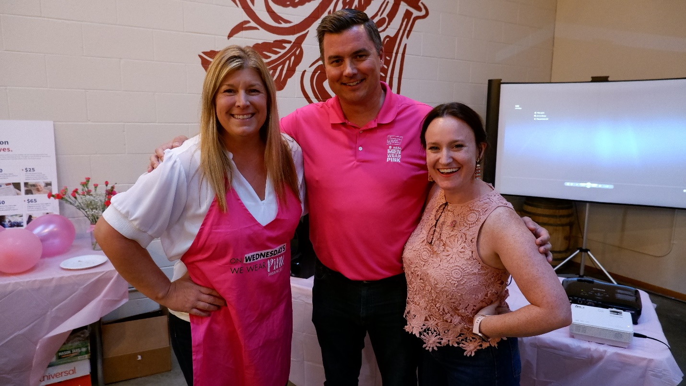
2- Real Men Wear Pink leadership team, pictured left to right Kristen Sallady (ACS), James Conners (Country Financial, ambassador and co-chair), Laura Brown (OCCU, co-chair).

