CONTACT
Laura Brown
Community Engagement &
Foundation Operations Manager
541.681.6321

LBrown@MyOCCU.org

Date: 12.6.22
For immediate release

OCCU CDO named local Real Men Wear Pink Ambassador of the Year

Eugene, Oregon – OCCU Chief Digital Officer Brian Alfano raised more than $25,000 for the American Cancer Society’s Real Men Wear Pink breast cancer fundraising campaign, catapulting him to win the award for top local fundraiser and Real Men Wear Pink Ambassador of the Year for Lane County.

The annual fundraiser brings together men of diverse backgrounds to promote breast cancer awareness, screening and treatment. Alfano and 13 other area leaders wore pink and engaged the community throughout the month of October to raise donations and inspire their peers to take action in the fight to end breast cancer. It was Alfano’s second year participating.

OCCU actively supported Alfano in his fundraising efforts. OCCU Foundation, OCCU’s philanthropic arm, added to Alfano’s campaign by matching $10,000 of all donations received, and OCCU employees organized a poll so that donors of $2.50 or more could choose a pink-themed costume for Alfano to wear to work for a day.

Alfano dressed as a whoopee cushion on Oct. 28 and dyed his hair pink. Altogether, OCCU employee contributions exceeded $2,000.

“It’s an honor to be a Real Men Wear Pink Ambassador for the American Cancer Society. Being able to raise funds for breast cancer patients, programs and research means a lot to OCCU and to me personally,” said Alfano. “OCCU is committed to the wellbeing of our community, and I’m hopeful that through this campaign we will save more lives from such a devastating disease.”

Altogether, the 14 Lane County ambassadors of Real Men Wear Pink raised more than $180,000. Proceeds benefit the American Cancer Society, which supports early detection initiatives, cancer research and patient care.

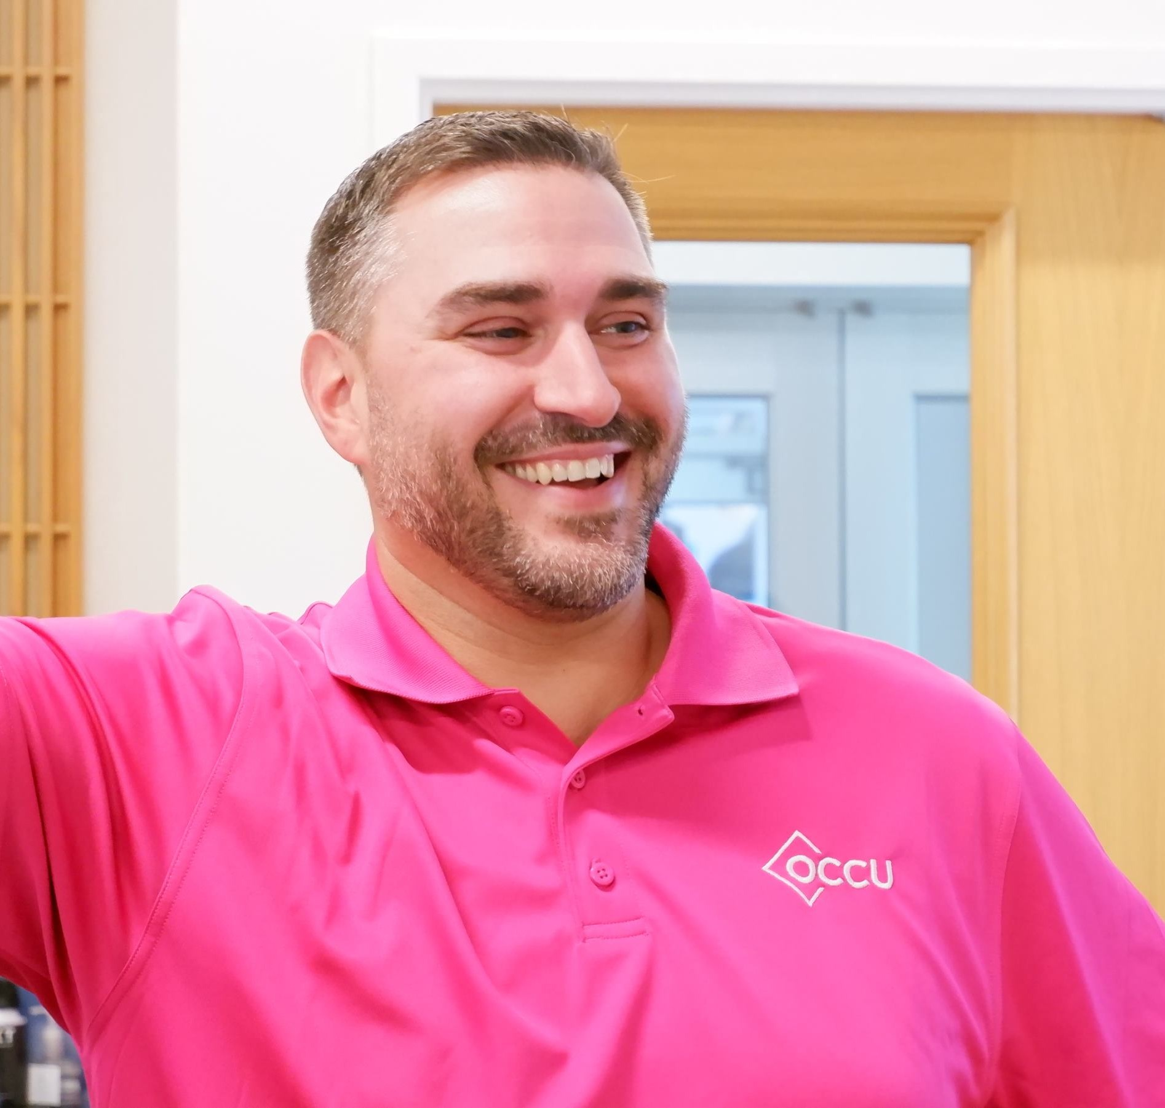
OCCU Chief Digital Officer Brian Alfano

About OCCU
OCCU was founded in 1956 in Eugene, Oregon. Today, as a not-for-profit financial cooperative, OCCU has more than $3 billion in assets and serves more than 250,000 members through digital channels and 12 Oregon branches in Eugene, Junction City, Keizer, Salem, Springfield and Wilsonville. Most members live in Oregon and the state of Washington. Others reside throughout the United States and even abroad, keeping their membership active through online and mobile banking. Learn more at MyOCCU.org.

# # #

