NEWS RELEASE
LEGALLY BLONDE – THE MUSICAL
The Hult Center, Eugene, OR, presented by The American Theatre Guild
February 3–5, 2023

FOR IMMEDIATE RELEASE
January 20, 2023

Contact:
Cathy Long
Senior Communications Manager
The American Theatre Guild
Cell: 515-778-2564
Cathy.Long@ATGuild.org
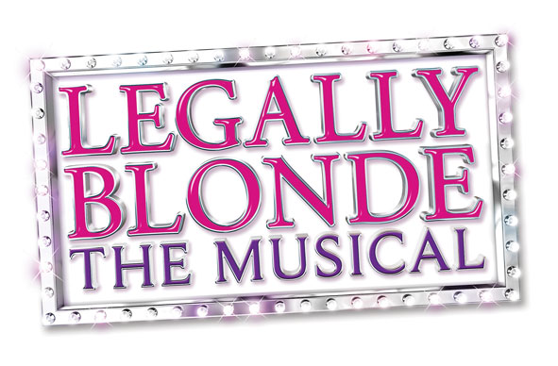
OMG YOU GUYS!
LEGALLY BLONDE – THE MUSICAL
COMES TO THE HULT CENTER FEBRUARY 3–5, 2023
Tickets Available Now!

EUGENE, OR ― The American Theatre Guild is pleased to present the ultimate Broadway tribute to girl power, LEGALLY BLONDE – THE MUSICAL. This production is part of the BROADWAY IN EUGENE SERIES and will take the Hult Center stage February 3–5, 2023.

Tickets to LEGALLY BLONDE – THE MUSICAL can be purchased at BroadwayinEugene.com, hultcenter.org or by calling 1-541-682-5000. Group ticket savings for 10+ are available by contacting Groups@ATGuild.org.

ASSETS: https://app.box.com/s/5dfjxuvoicql7lu2i9jy8evmvjozs4ts

PERFORMANCE SCHEDULE:

Friday, February 3, 2023 8:00 p.m.
Saturday, February 4, 2023 2:00 & 8:00 p.m.
Sunday, February 5, 2023 1:00 p.m.

America’s favorite blonde, Elle Woods, is ready to prove who’s in charge (again) as Legally Blonde - The Musical comes to the Hult Center in Eugene! -more-
The ultimate Broadway tribute to girl power, Legally Blonde will take you from the UCLA sorority house to the Harvard halls of justice with its coming-of-age story.

Based on the iconic movie, Legally Blonde follows the transformation of Elle Woods as she tackles stereotypes, sexism, snobbery and scandal in pursuit of her dreams, and proves, contrary to dated bias, that you can be both legally blonde AND the smartest person in the room.

Things are groovy for Elle Woods but suddenly her life is turned upside down when her boyfriend dumps her so he can start getting more “serious” about his life and attend Harvard Law. Determined to get him back, Elle uses her brain and ingenuity to also get admitted to Harvard. School begins with endless struggles, but with the help of her new friends, Elle quickly realizes her potential and her strengths, as she sets out to change the narrative. This contemporary, topical story touches on many current hot button issues while delighting audiences with memorable songs and explosive dances. Legally Blonde warms the heart by proving that self-discovery never goes out of style!

The 2022-2023 National Tour of Legally Blonde is produced by Daniel Sher of Big League Productions, Inc. The musical is directed by Jeffrey B. Moss, with choreography by Bob Richard. Set design is by Randel Wright, with lighting by Charlie Morrison and stunning new elaborate video design by Jon Infante. Casting is by Alison Franck.

For more information, visit www.BlondeOnTour.com.

Led by President and Executive Producer Dan Sher, Big League is celebrating its 31st season of producing, general managing and booking Broadway musicals and special attractions for touring throughout North America and the world. For more information visit www.BigLeague.org.

Please Note: BroadwayinEugene.com, hultcenter.org and the Hult Center Box Office are the only official sources for tickets to all shows in the 22–23 BROADWAY IN EUGENE SERIES. If you purchase tickets through another source, you may pay inflated prices and your tickets will not be guaranteed.

The 22–23 BROADWAY IN EUGENE SERIES is welcomed by the Hult Center.

Become a fan of Broadway by following us on social media.

• Facebook: @BroadwayInEugene
• Instagram: @BwayInEugene
• Twitter: @BwayInEugene

Staging the Future
A program created by The American Theatre Guild to foster passion, inspire creativity and empower the members of our communities. Staging the Future enables students and underserved community members the ability to experience live theatre and provides access to education opportunities. The program is funded by the generosity of The American Theatre Guild season members and donors. For more information, please visit https://americantheatreguild.com/education/.

The American Theatre Guild
A 501(c)(3) organization and the largest not-for-profit touring Broadway Presenter in the nation, supports Broadway seasons in
16 markets including: Birmingham, AL; Colorado Springs, CO; Eugene, OR; Honolulu, HI; Kansas City, MO; Long Beach, CA; Lubbock, TX; Melbourne, FL; Peoria, IL; Phoenix, AZ; Riverside, CA; Santa Barbara, CA; South Bend, IN; Thousand Oaks, CA; Toledo, OH; and Wichita, KS. The American Theatre Guild is dedicated to providing the experience of live theater in order to foster passion, inspire creativity and empower youth within each community.
# # #

