CONTACT
Laticia Duman
Communications Content Specialist
541.681.5285 (desk)
LDuman@MyOCCU.org

Date: 2.21.23
For immediate release

Eugene, Oregon – OCCU hires two leaders

OCCU welcomes Genevieve Sumnall as VP of business services and has promoted Cheleana Stafflund to director of retail operations. Both Sumnall and Stafflund started their new roles in Jan. 2023.

As VP of Business Services, Genevieve Sumnall’s responsibilities include building upon relevant products and services and deepening relationships with small businesses in the communities OCCU serves.
Sumnall has previously held vice president and treasury management roles with some of the largest banks in the region. She is a member of the board of directors of Habitat for Humanity of Central Lane, a 20 under 40 Award recipient and graduate of the Leadership Eugene Springfield civic leadership and advocacy program.
Cheleana Stafflund began her career with OCCU as a regional manager in 2022. Stafflund has nearly ten years of regional operations management, including as a vice president at Columbia Bank. She is also a graduate of the Leadership Eugene Springfield program and has served on several boards of civic organizations. As Director of Retail Operations, Stafflund leads all branches, ensuring each branch meets organizational, financial, operational, service, security and growth benchmarks.
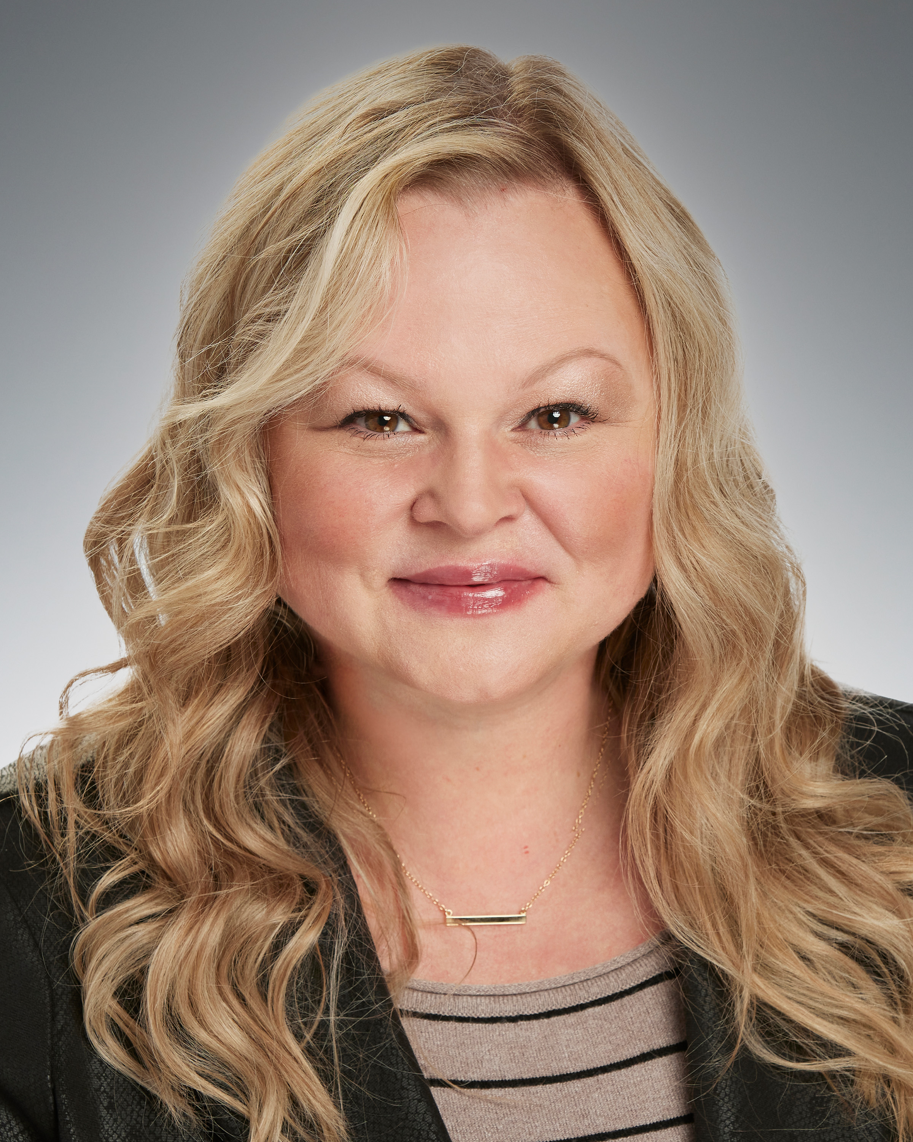
Left: Genevieve Sumnall
Right: Cheleana Stafflund

About OCCU
OCCU was founded in 1956 in Eugene, Oregon. Today, as a not-for-profit financial cooperative, OCCU has more than $3 billion in assets and serves more than 250,000 members through digital channels and 13 Oregon branches in Eugene, Junction City, Keizer, Redmond, Salem, Springfield and Wilsonville. Most members live in Oregon and the state of Washington. Others reside throughout the United States and even abroad, keeping their membership active through online and mobile banking. Learn more at MyOCCU.org.

# # #

