NEWS RELEASE
Show Information: COME FROM AWAY
The Hult Center, Eugene, OR, presented by The American Theatre Guild
April 25–30, 2023

FOR IMMEDIATE RELEASE
March 16, 2023

Contact:
Cathy Long
Senior Communications Manager
The American Theatre Guild
Cell: 515-778-2564
Cathy.Long@ATGuild.org
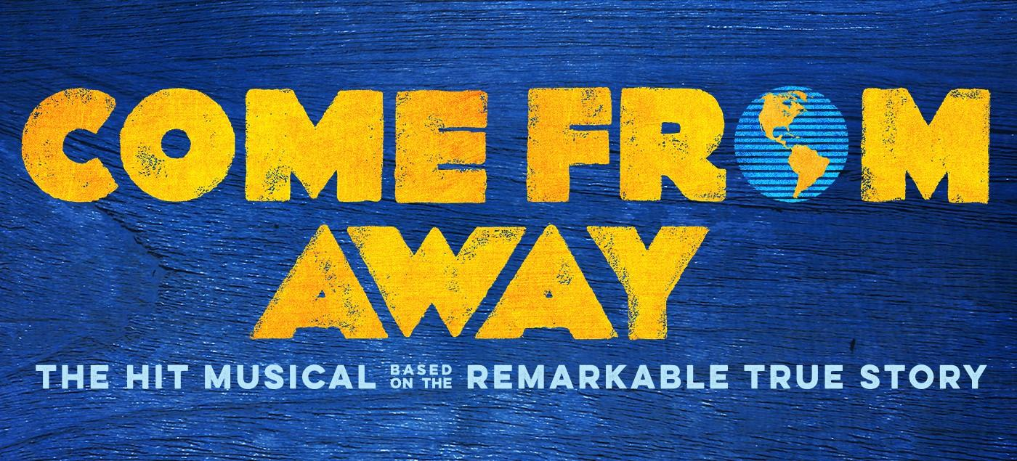

THE TONY & OLIVIER AWARD-WINNING
“MUST-SEE MUSICAL” (NPR) COME FROM AWAY
IS ON SALE NOW!

EUGENE, OR ― The American Theatre Guild is thrilled to present the must-see engagement of COME FROM AWAY, a Broadway musical about the true story of the small town that welcomed the world. This production is part of the BROADWAY IN EUGENE SERIES and will take the Hult Center stage for eight performances April 25–30, 2023.

Tickets to COME FROM AWAY can be purchased at BroadwayinEugene.com, hultcenter.org or by calling 1-541-682-5000. Group ticket savings for 10+ are available by contacting Groups@ATGuild.org.

ASSETS: https://app.box.com/s/6r3aoms24l218h88khz65mv5vl2ed4do

PERFORMANCE SCHEDULE:
Tuesday, April 25, 2023 7:30 p.m.
Wednesday, April 26, 2023 7:30 p.m.
Thursday, April 27, 2023 7:30 p.m.
Friday, April 28, 2023 8:00 p.m.
Saturday, April 29, 2023 2:00 & 8:00 p.m.
Sunday, April 30, 2023 1:00 & 6:30 p.m.

-more-

The touring production of COME FROM AWAY currently stars Marika Aubrey, Kevin Carolan, Harter Clingman, Christine Toy Johnson, Julie Johnson, James Earl Jones II, James Kall, Julia Knitel, Ali Momen, Kristen Peace, Danielle K. Thomas, Jeremy Woodard, Jordan Barbour, Clint Butler, Kate Etienne, Amir Haidar, Phyre Hawkins and Cailin Stadnyk.

COME FROM AWAY features a book, music and lyrics by Olivier, Drama Desk and Outer Critics Circle Award winners and Grammy and two-time Tony Award nominees Irene Sankoff & David Hein, direction by Tony Award winner and Outer Critics Circle Award winner Christopher Ashley, musical staging by Olivier Award winner and two-time Tony Award nominee Kelly Devine, and music supervision by Olivier Award winner and Grammy Award nominee Ian Eisendrath.

COME FROM AWAY features scenic design by Tony Award winner Beowulf Boritt, costume design by Tony Award nominee Toni-Leslie James, lighting design by two-time Tony Award winner Howell Binkley, sound design by Olivier & Outer Critics Circle Award winner and Tony Award nominee Gareth Owen, orchestrations by Olivier Award winner and Grammy & Tony Award nominee August Eriksmoen, and music arrangements by Olivier Award winner and Grammy Award nominee Ian Eisendrath and casting by Telsey + Company.

COME FROM AWAY tells the remarkable true story of 7,000 stranded passengers and the small town in Newfoundland that welcomed them. Cultures clashed and nerves ran high, but uneasiness turned into trust, music soared into the night, and gratitude grew into enduring friendships.

On September 11, 2001 the world stopped. On September 12, their stories moved us all.

A “Best Musical” winner all across North America, the smash hit musical has won the Tony Award for “Best Direction of a Musical” (Christopher Ashley), 4 Olivier Awards (London) including “Best New Musical,” 5 Outer Critics Circle Awards (NYC) including “Outstanding New Broadway Musical,” 3 Drama Desk Awards (NYC) including “Outstanding Musical,” 4 Los Angeles Drama Critics Circle Awards (North American Tour) including “Best Production,” 4 Helen Hayes Awards (D.C.) including “Outstanding Production of a Musical,” 4 Gypsy Rose Lee Awards (Seattle) including “Excellence in Production of a Musical,” 6 San Diego Critics Circle Awards including “Outstanding New Musical,” 3 Toronto Theatre Critics Awards including “Best New Musical,” 3 Dora Awards (Toronto) including “Outstanding New Musical/Opera” and “Outstanding Production,” and the 2017 Jon Kaplan Audience Choice Award (Toronto).

The Grammy Award-nominated original Broadway cast recording of COME FROM AWAY is available digitally and in stores everywhere. Grammy Award winner David Lai, and Grammy Award nominees Ian Eisendrath, August Eriksmoen, Irene Sankoff & David Hein served as album producers.

Apple Original Films’ filmed version of the Tony & Olivier Award-winning hit musical COME FROM AWAY, produced by eOne, Hasbro’s entertainment studio, premiered globally on Apple TV+ on Friday, September 10, 2021. COME FROM AWAY, which marks the first Broadway show to be streamed by Apple TV+, is directed by Tony Award-winner Christopher Ashley, who directed the original Broadway production, and stars an ensemble cast led by members of the Broadway show. The live performance of COME FROM AWAY was filmed in New York at the Gerald Schoenfeld Theatre in May 2021, where the Broadway production is staged, for an audience that included 9/11 survivors and front-line workers; and, employed over 200 people including members of the Broadway crew, staff and creative teams.

COME FROM AWAY is produced by Junkyard Dog Productions (Randy Adams, Marleen and Kenny Alhadeff and Sue Frost), Jerry Frankel, Latitude Link, Smith & Brant Theatricals, Steve & Paula Reynolds, David Mirvish, Michael Rubinoff, Alhadeff Productions, Michael Alden & Nancy Nagel Gibbs, Sam Levy, Rodney Rigby, Spencer Ross, Richard Winkler, Yonge Street Theatricals, Sheridan College, Michael & Ellise Coit, Ronald Frankel, Sheri & Les Biller, Richard & Sherry Belkin, Marlene & Gary Cohen, Allan Detsky & Rena Mendelson, Lauren Doll, Barbara H. Freitag, Wendy Gillespie, Laura Little Theatricals, Carl & Jennifer Pasbjerg, Radio Mouse Entertainment, The Shubert Organization, Cynthia Stroum, Tulchin Bartner Productions, Gwen Arment/Molly Morris & Terry McNicholas, Maureen & Joel Benoliel/Marjorie & Ron Danz, Pamela Cooper/Corey Brunish, Demos Bizar/Square 1 Theatrics, Joshua Goodman/Lauren Stevens, Adam Blanshay Productions/Judith Ann Abrams Productions, Bill & Linda Potter/Rosemary & Kenneth Willman, and La Jolla Playhouse and Seattle Repertory Theatre.

COME FROM AWAY was originally co-produced in 2015 by La Jolla Playhouse and Seattle Repertory Theatre, and presented in 2016 by Ford’s Theatre in Washington, DC and Mirvish Productions at the Royal Alexandra Theatre in Toronto, CA. COME FROM AWAY (NAMT Festival 2013) was originally developed at the Canadian Music Theatre Project, Michael Rubinoff Producer, Sheridan College in Oakville, Ontario, Canada and was further developed at Goodspeed Musicals’ Festival of New Artists, in East Haddam, CT. The Canada Council for the Arts, The Ontario Arts Council, and the Fifth Avenue Theatre in Seattle WA also provided development support.
-more-
Please visit: www.ComeFromAway.com

Connect with COME FROM AWAY
Facebook: https://www.facebook.com/ComeFromAway/
Twitter: @Wecomefromaway
Instagram: @Wecomefromaway

Please Note: BroadwayinEugene.com, hultcenter.org and the Hult Center Box Office are the only official sources for tickets to all shows in the 22–23 BROADWAY IN EUGENE SERIES. If you purchase tickets through another source, you may pay inflated prices and your tickets will not be guaranteed.

The 22–23 BROADWAY IN EUGENE SERIES is welcomed by the Hult Center.

Become a fan of Broadway by following us on social media.

• Facebook: @BroadwayInEugene
• Instagram: @BwayInEugene
• Twitter: @BwayInEugene

Staging the Future
A program created by The American Theatre Guild to foster passion, inspire creativity and empower the members of our communities. Staging the Future enables students and underserved community members the ability to experience live theatre and provides access to education opportunities. The program is funded by the generosity of The American Theatre Guild season members and donors. For more information, please visit https://americantheatreguild.com/education/.

The American Theatre Guild
A 501(c)(3) organization and the largest not-for-profit touring Broadway Presenter in the nation, supports Broadway seasons in
16 markets including: Birmingham, AL; Colorado Springs, CO; Eugene, OR; Honolulu, HI; Kansas City, MO; Long Beach, CA; Lubbock, TX; Melbourne, FL; Peoria, IL; Phoenix, AZ; Riverside, CA; Santa Barbara, CA; South Bend, IN; Thousand Oaks, CA; Toledo, OH; and Wichita, KS. The American Theatre Guild is dedicated to providing the experience of live theater in order to foster passion, inspire creativity and empower youth within each community.
# # #

