CONTACT
Laura Brown
Community Engagement &
Foundation Operations Manager
541.681.5285
LBrown@MyOCCU.org

Date: 4.26.23
For immediate release

OCCU Foundation partners with Lane Community College Foundation

to support general scholarships

Eugene, Oregon – OCCU Foundation, the philanthropic arm of OCCU, announces its renewed commitment to accessible education in partnership with Lane Community College (LCC) Foundation, committing $30,000 for scholarships.

Five full-time students will receive full-tuition scholarships for the 2023-24 academic year. Lane County residents of any major are eligible to apply through the LCC Foundation for this funding. In addition, three OCCU team members will once again utilize paid time to volunteer more than 50 total hours this April reading and evaluating scholarship applications through OCCU’s Community Outreach for Employees (CORE) program.

“Access to education is important to OCCU Foundation,” said Heather Billings, OCCU Foundation board secretary and OCCU chief marketing officer. “We believe that when students are given the opportunity to grow academically and professionally, they’re more likely to make a positive impact in their communities, and partnering with LCC on these scholarships is one way to help create that opportunity.”

The relationship between OCCU and LCC dates back to 1990, and OCCU has been a major contributor to the scholarship program since 1998. Cumulatively, both OCCU and OCCU Foundation have contributed more than $388,000 to LCC to support students through scholarships and programming.

Since 2010, 37 full-tuition scholarships from OCCU and OCCU Foundation have been awarded to students. In addition, OCCU’s giving program has expanded from a single annual scholarship to five as OCCU Foundation’s support has grown and diversified over the years to meet LCC’s areas of greatest need.

“OCCU Foundation gives critical support to provide accessible education to local LCC students,” said Tiana Marrone, Development Director of the Lane Community College Foundation. “We’re grateful for this longstanding relationship, and we’re looking forward to seeing how it evolves in the future.”

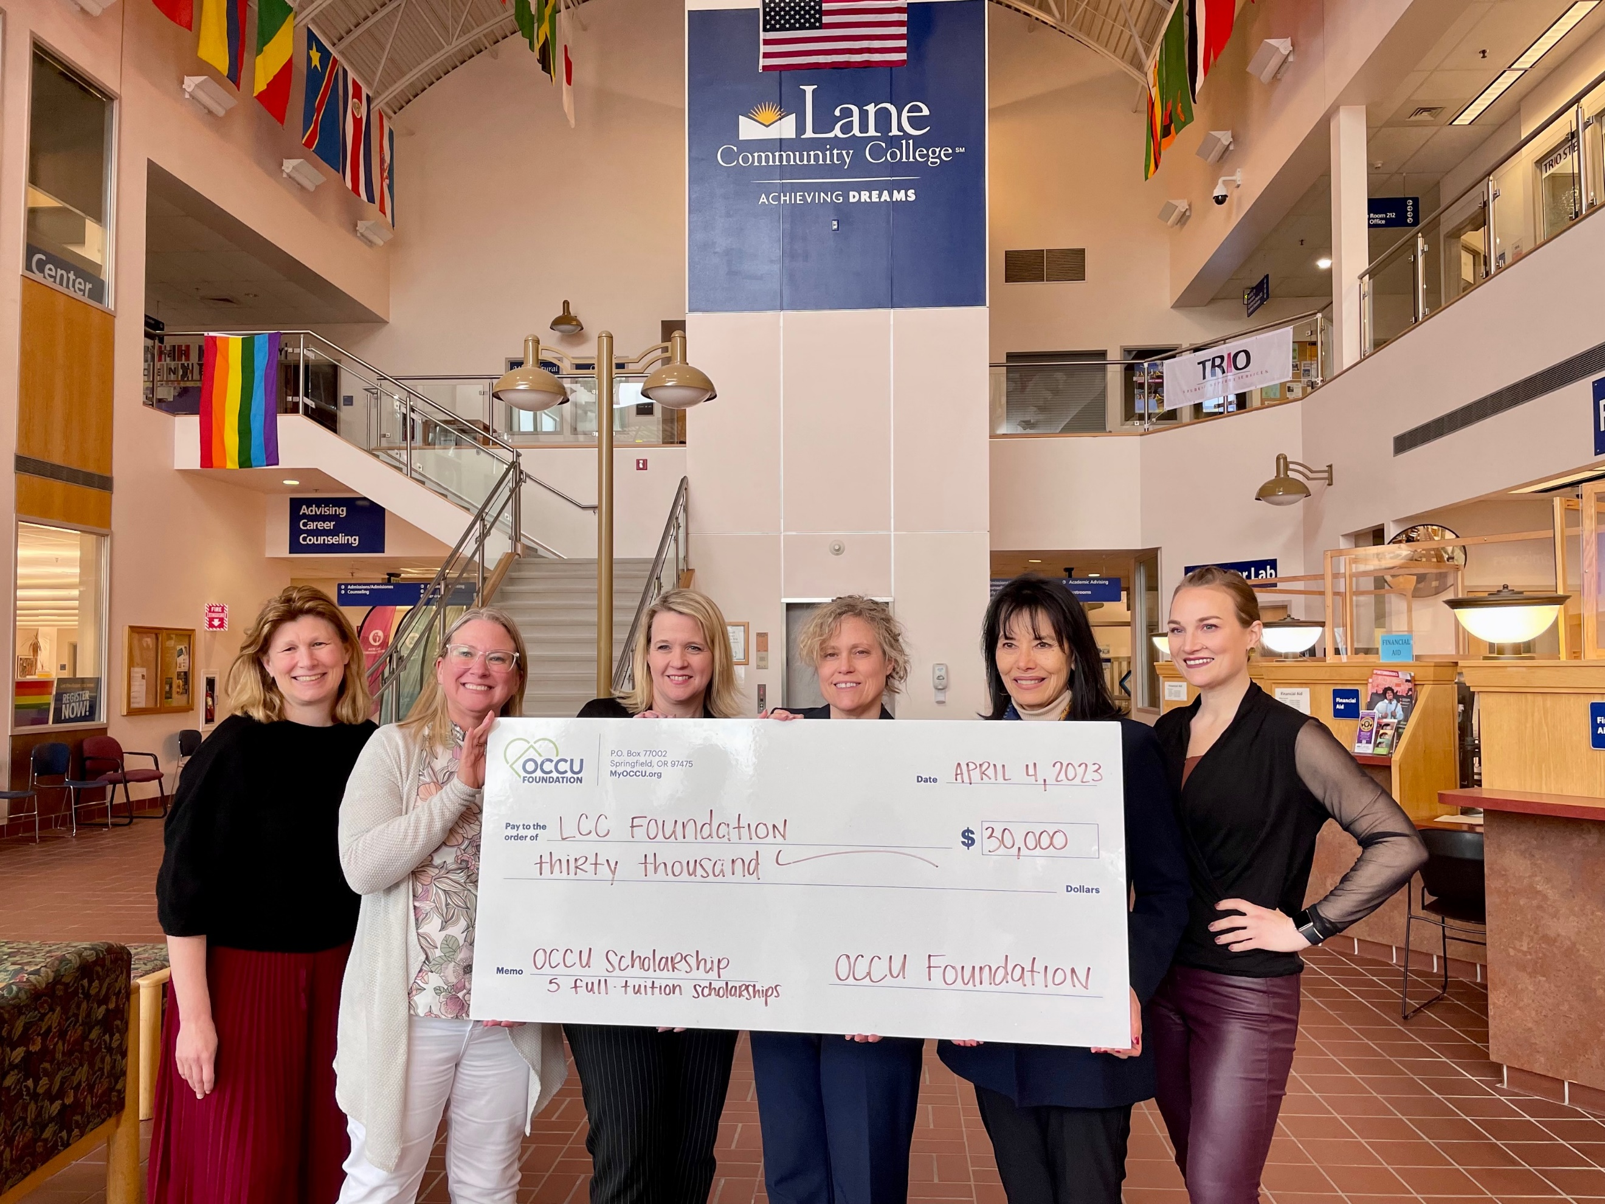
OCCU Foundation board member Tracey Keffer and OCCU Foundation Board Secretary Heather Billings (second and third from left, respectively) present LCC Foundation representatives with $30,000 in scholarship funds.

About Lane Community College
The mission of Lane Community College is to provide comprehensive, accessible, quality, learning-centered educational opportunities that promote student success with a vision of transforming lives through learning.

About OCCU Foundation
OCCU Foundation is the philanthropic arm of OCCU, a not-for-profit financial cooperative located in Oregon and Washington. Since its start, OCCU Foundation has granted more than $2.5 million to help build happier and healthier communities by giving generously to projects that advance learning, improve well-being and support communities. The foundation is a nonprofit 501(c)(3) corporation funded by OCCU, businesses, families and individuals. OCCU Foundation was founded in 2018 to further extend the credit union’s vision to Enrich Lives. Learn more at MyOCCU.org/Foundation.

About OCCU
OCCU is a not-for-profit financial cooperative with more than $3 billion in assets. Founded in Eugene, OR, in 1956, OCCU has an expanding network of branches and web tools to provide its more than 260,000 member-owners with a full suite of financial services. Membership is open to anyone living or working in 28 Oregon counties or anywhere in Washington. Learn more at MyOCCU.org.
# # #

