NEWS RELEASE
Show Information: ANASTASIA
The Hult Center, Eugene, OR, presented by The American Theatre Guild
May 12–14, 2023

FOR IMMEDIATE RELEASE
May 2, 2023

Contact:
Cathy Long
Senior Communications Manager
The American Theatre Guild
Cell: 515-778-2564
Cathy.Long@ATGuild.org

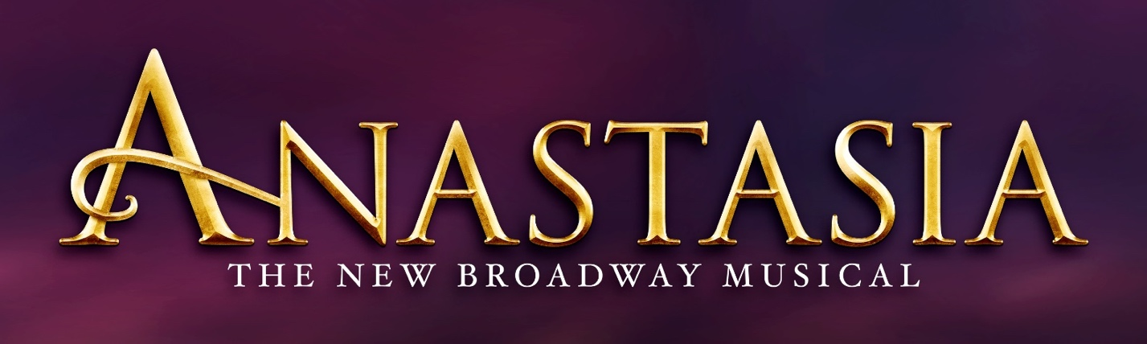

Tickets for the Eugene Premiere of
Anastasia
Are On Sale Now!

EUGENE, OR ― The American Theatre Guild is thrilled to present the dazzling new Broadway musical, ANASTASIA. This production is part of the 22-23 BROADWAY IN EUGENE SERIES and will take the Hult Center stage May 12–14, 2023.

Tickets to ANASTASIA can be purchased at BroadwayinEugene.com, hultcenter.org or by calling 1-541-682-5000. Group ticket savings for 10+ are available by contacting Groups@ATGuild.org.

ASSETS: https://app.box.com/s/e835qn3y8a1ry6xy1vzq780blpz9x788

PERFORMANCE SCHEDULE:

Friday, May 12, 2023 8:00 p.m.
Saturday, May 13, 2023 2:00 & 8:00 p.m.
Sunday, May 14, 2023 1:00 p.m.
-more-
From the Tony Award-winning creators of the Broadway classic Ragtime and inspired by the beloved films, ANASTASIA is the new Broadway musical that’s “one of the most gorgeous shows in years!” (New York Observer). This dazzling show transports us from the twilight of the Russian Empire to the euphoria of Paris in the 1920s, as a brave young woman sets out to discover the mystery of her past. Pursued by a ruthless Soviet officer determined to silence her, Anya enlists the aid of a dashing conman and a lovable ex-aristocrat. Together, they embark on an epic adventure to help her find home, love, and family.

The cast includes Veronica Stern as Anya, Willem Butler as Dmitry, Christian McQueen as Gleb, Gerri Weagraff as Dowager Empress, Bryan Seastrom as Vlad, Madeline Raube as Countess Lily and Adriella Goncalves and Alexandrya Salazar as Little Anastasia. The ensemble includes Thalia Atallah, Zachary Bigelow, Danny Martin, Louis Brogna, Lauren Teyke, Amin Fuson, Rebecca Hartman, Kaitlyn Jackson, Brooklyn Libao, Alec Lloyd, Zoie Lee, Billy McGavin, Dominic Pagliaro, Luke Rands, Lathan A. Roberts, Amy Smith, and Sarah Statler.

ANASTASIA features a book by celebrated playwright the late Terrence McNally, a lush, new score by the Tony Award® -winning creators of the Broadway classic Ragtime, Stephen Flaherty (music) and Lynn Ahrens (lyrics), and tour direction by Sarah Hartman based on original direction by Tony Award®-winning director Darko Tresnjak.

The creative team also includes Peggy Hickey (Original Choreographer), Bill Burns (Choreographer), Alexander Dodge (Set Design), Linda Cho (Costume Design), Donald Holder (Lighting Design), Peter Hylenski (Sound Design), Aaron Rhyne (Projection Design), Charles G. LaPointe (Hair/Wig Design), Joe Dulude II (Makeup Design), Tom Murray (Music Supervision), Glenn Alexander II (Music Direction), Doug Besterman (Orchestrations), David Chase (Dance Arranger), and casting by Jason Styres, CSA.

ANASTASIA began performances on Broadway in March 2017 at the Broadhurst Theatre with critics exclaiming “Ahrens and Flaherty have chosen the right moments to musicalize, and their score here sounds complete and full — one of the season’s strongest! (NBC)” and “Smartly adapted by Terrence McNally, Anastasia is a sweeping adventure, romance and historical epic whose fine craftsmanship will satisfy musical-theater fans (Time Out)”.

The show played to sold out audiences on Broadway for more than 3 years before expanding its global “Fanastasia” community with productions on tour across North America and in Japan, Spain, Germany and the Netherlands. Globally, the show has been performed more than 2,500 times and sold 3.4 million tickets. Additionally, the show has garnered more than 15 major international awards, including Tony, Drama Desk and Outer Critics Circle awards and Best New Musical in Spain, Germany and the Netherlands.

The original Broadway cast recording is available at BroadwayRecords.com, Amazon.com and iTunes. The 75-minute album includes the Academy Award-nominated favorite “Journey to the Past” alongside new numbers from the show such as “In My Dreams,” “Still” and “My Petersburg.”

Please Note: BroadwayinEugene.com, hultcenter.org and the Hult Center Box Office are the only official sources for tickets to all shows in the 22–23 BROADWAY IN EUGENE SERIES. If you purchase tickets through another source, you may pay inflated prices and your tickets will not be guaranteed.

The 22–23 BROADWAY IN EUGENE SERIES is welcomed by the Hult Center.

Become a fan of Broadway by following us on social media.

• Facebook: @BroadwayInEugene
• Instagram: @BwayInEugene
• Twitter: @BwayInEugene

Staging the Future
A program created by The American Theatre Guild to foster passion, inspire creativity and empower the members of our communities. Staging the Future enables students and underserved community members the ability to experience live theatre and provides access to education opportunities. The program is funded by the generosity of The American Theatre Guild season members and donors. For more information, please visit https://americantheatreguild.com/education/.

The American Theatre Guild
A 501(c)(3) organization and the largest not-for-profit touring Broadway Presenter in the nation, supports Broadway seasons in
16 markets including: Birmingham, AL; Colorado Springs, CO; Eugene, OR; Honolulu, HI; Kansas City, MO; Long Beach, CA; Lubbock, TX; Melbourne, FL; Peoria, IL; Phoenix, AZ; Riverside, CA; Santa Barbara, CA; South Bend, IN; Thousand Oaks, CA; Toledo, OH; and Wichita, KS. The American Theatre Guild is dedicated to providing the experience of live theater in order to foster passion, inspire creativity and empower youth within each community.
# # #

