CONTACT
Griffin Edwards
Community Engagement
Communications Specialist
541.334.8614

GEdwards@MyOCCU.org

Date: 6.26.23
For immediate release

OCCU team leverages corporate volunteer benefits to maintain Oregon nature preserve

Eugene, Oregon – A team from OCCU recently used corporate paid volunteer time benefits to perform trail maintenance work at a local Eugene, OR, nature reserve.

OCCU’s Organizational Development team, which includes employee engagement, training and DEI professionals, coordinated three and a half hours of volunteer time with management of the Howard Buford Recreation Area outside Eugene. Twelve team members spent the morning of May 18 removing branches and invasive blackberry bushes from public trails on Mount Pisgah, a favorite local nature spot.

The team took advantage of OCCU’s corporate volunteer time off benefit, CORE (Community OutReach for Employees). Through the CORE program, staff are allocated forty paid hours each year to spend volunteering at nonprofits they are passionate about. In 2022 alone, OCCU staff redeemed 945 CORE Time hours.

“We had a great time talking and joking together, enjoying the views and feeling pride to look back at the trail and see our impact!” said Erin Ocean, one of the team members who led the volunteer effort. “CORE time is an amazing benefit at OCCU. It helps our employees live our core value of bigheartedness and shows OCCU's true, deep commitment to improving and supporting our local communities.”

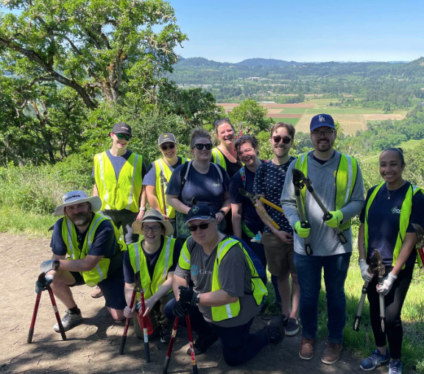
OCCU’s OrgDev team poses on a trail at Mount Pisgah, where they used OCCU’s corporate volunteer hour benefit to clear trails for hikers.

About OCCU Foundation
OCCU Foundation is the philanthropic arm of OCCU, a not-for-profit financial cooperative located in Oregon and Washington. Since its start, OCCU Foundation has granted more than $2.5 million to help build happier and healthier communities by giving generously to projects that advance learning, improve well-being and support communities. The foundation is a nonprofit 501(c)(3) corporation funded by OCCU, businesses, families and individuals. OCCU Foundation was founded in 2018 to further extend the credit union’s vision to Enrich Lives. Learn more at MyOCCU.org/Foundation.

About OCCU
OCCU is a not-for-profit financial cooperative with more than $3.4 billion in assets. Founded in Eugene, OR, in 1956. OCCU is a credit union with an expanding network of branches and web tools to provide its 275,000+ member-owners with a full suite of financial services. Membership is open to anyone living or working in 28 Oregon counties or anywhere in Washington. Learn more at MyOCCU.org.
# # #

