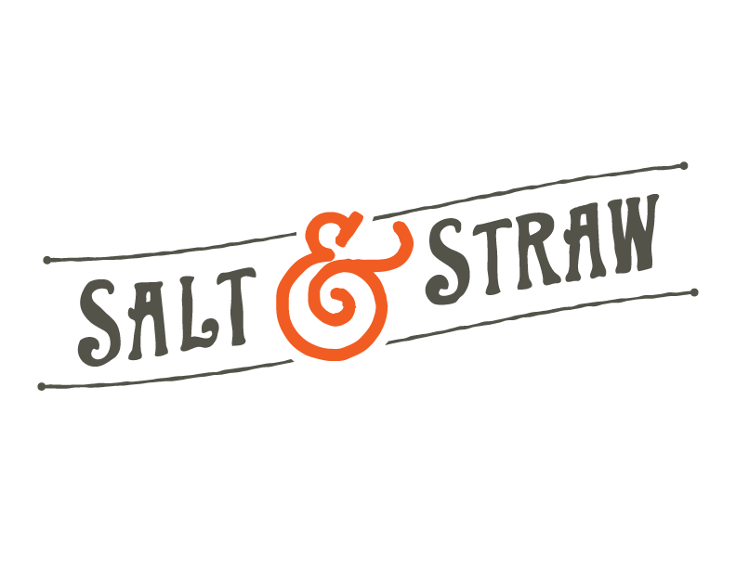
Salt & Straw to Release New Scoops & Skulls Menu in Celebration of Halloween and Dia de los Muertos Starting Friday, September 29
New Flavor Collaborations with Mexican Female Entrepreneurs
and Free Scoops for Kids in Costume on Halloween

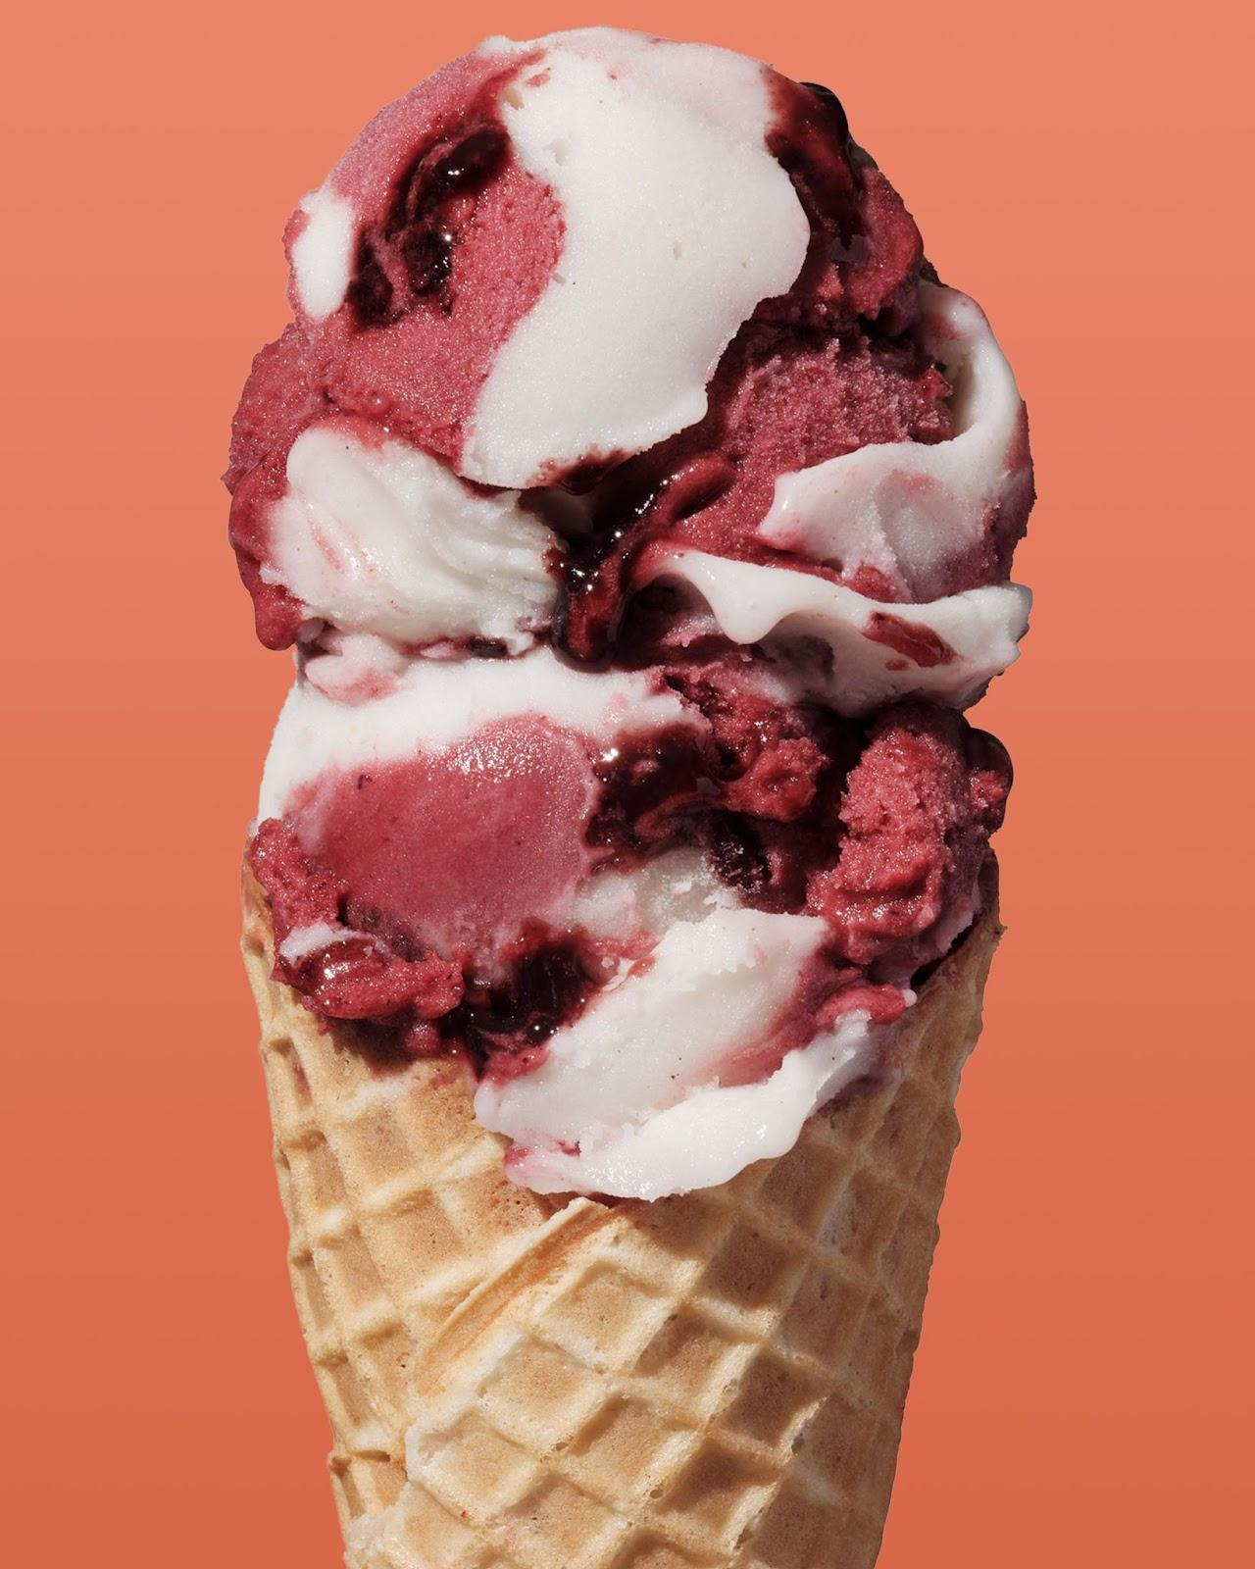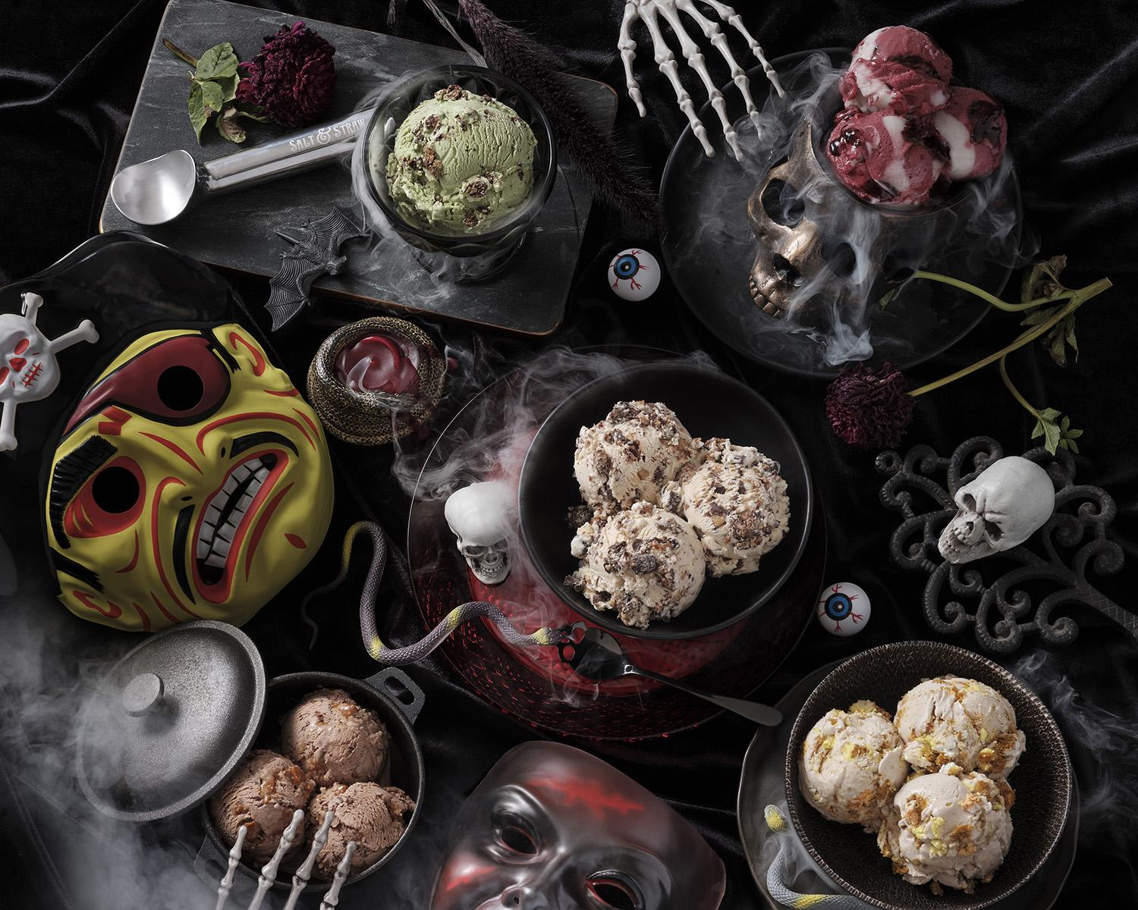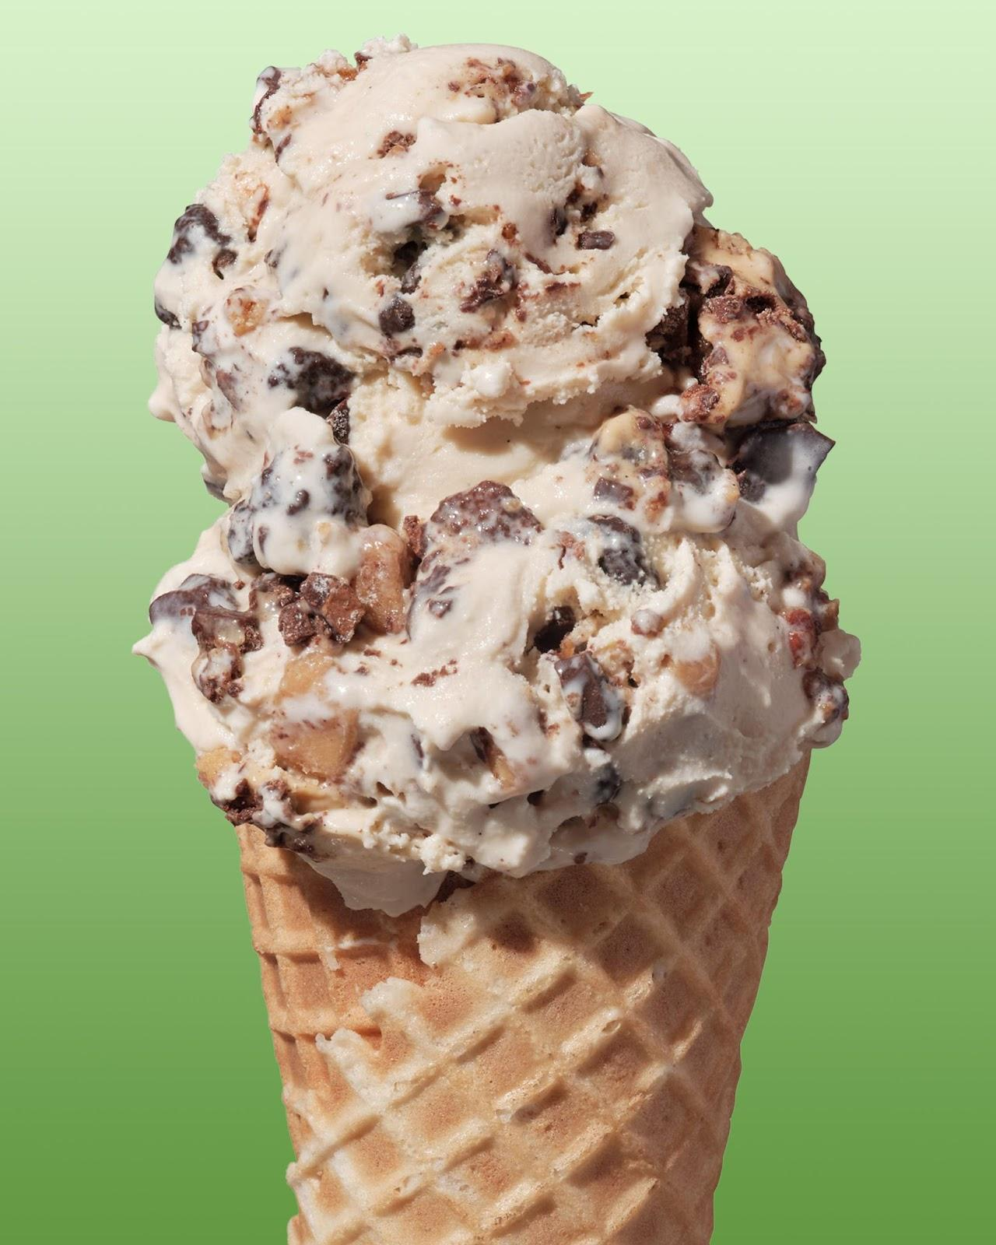

Photos (credit Salt & Straw) available here

PORTLAND, OR. (Sept. 26, 2023) - Salt & Straw Ice Cream will launch its Scoops & Skulls flavor series starting on Friday, Sept. 29. Designed to celebrate the Halloween and Dia de los Muertos holidays, this year’s menu celebrates the traditions of the season with the return of three beloved flavors in addition to two new flavors made in partnership with recipe writer Paola Briseño González.

Salt & Straw will also offer free kid’s scoops for children under 16 in costumes at all scoop shops on Halloween, Tuesday, October 31. Its Halloween-inspired menu can be traced all the way back to when the company first opened its doors on Alberta Street in Portland.

Salt & Straw’s collaboration with Paola Briseño González will showcase the first year of adding Dia de los Muertos to the seasonal menu. Briseño González is originally from Puerto Vallarta and has been a longtime friend of Salt & Straw co-founder, Tyler Malek. They first met at the Food Innovation Center in Portland when Salt & Straw was first getting started. Her work has appeared in Food & Wine, Food Network, Epicurious and more, and she also leads LA’s Dia de los Muertos festival.

The brand’s famed partnership with Monica Martinez, founder of Don Bugito, will also return this season for the Creepy Crawly Critters flavor, which brings sweet green matcha ice cream together with Don Bugito’s chocolate crickets and toffee-brittle mealworms and has been on Salt & Straw’s Halloween menu since 2015.
Don't look now, but Halloween's just around the corner, coming to grab you where you live, with five ice creams so freakin' good they'll chill you to your bones. Come ring our doorbell... if you dare... and get into your very own tricky treat candy-copia, taste Don Bugito's Creepy Crawly Critters, and celebrate our sweet new collaborations in honor of Día de los Muertos. Fee, fie, fo, fun.... Something delicious this way comes.

This year’s Scoops & Skulls menu includes:

The Great Candycopia
- As darkness falls across the land, the witching hour is close at hand. Time to dump our bags of housemade trick-or-treat candy—inspired by Kit Kats, Snickers, Reeses and Heath bars—into diabolically delicious salted butterscotch ice cream. Come, feast on these vampire-size bites of crispy milk chocolate feuilletine, peanut butter trapped in walls of chocolate, and almonds smothered in BOOrbon vanilla toffee.

Jack o' Lantern Pumpkin Bread
- Hidden away in the back of an old cupboard is Grandma’s secret book of family spells. Wait, we mean... recipes. A whispered incantation: One crooked smile of Jack, a pinch of warming spice, tender hunks of pumpkin bread, and whipped up oh-so-nice... generous swaths of cream cheese frosting. Bite after tasty bite, it lights you up and leaves you grinning.

Don Bugito's Creepy Crawly Critters
- In the spirit of delicious temptation, we've collected a happy Halloween swarm of edible critters to tickle your tongue—and your fancy—in sweet green matcha ice cream. Mmmm. Don Bugito's munchy, crunchy chocolate crickets and toffee-brittle mealworms are a superfood delight. Have a good creepy night. (Made with Don Bugito's)

Chocolate Champurrado w/ Sesame Toffee
- We love collaborating with recipe writer Paola Briseño-González for this sweet Día de los Muertos inspiration. Honoring Mexico's rich cacao tradition, we brew a delicate, spiced champurrado (Cloudforest chocolate drink thickened with masa) and shower it with shards of sesame seed palanqueta (traditional Mexican-style sesame toffee). The crunchy toffee makes it a real textural celebration that blows up with skull-popping fireworks.
Blackberry & Masa Tamale Sherbet (v)
- An especially spirited scoop in honor of Día de los Muertos: One half masa coconut cream sherbet, one half juicy marionberry sherbet, this tasty treat is a tribute to Michoacán's tamal from the Purépecha region. It is all vegan and simply delicious. Made in collaboration with recipe writer Paola Briseño-González

All flavors are available at Salt & Straw scoop shops as scoops, pints and milkshakes; as well as available for local delivery via saltandstraw.olo.com and nationwide shipping through the company’s “Pints of the Month” pack or as a “Pick Your Pints” bundle.

# # #

About Salt & Straw Ice Cream:
Co-founded by cousins Kim and Tyler Malek, Salt & Straw is a Portland-based, family-run company making award-winning ice cream that tells the story of artisans, farmers and meaningful food moments. Head Ice Cream Innovator Tyler Malek, whose recipes have been published in numerous national food magazines, creates a menu of 13 classic flavors, alongside monthly rotating menus that reflect culinary trends, seasonality of ingredients and relevant cultural moments. From their humble beginnings as a single ice cream cart, Salt & Straw now has three scoop shops in Portland, one in Lake Oswego, Eugene, and Beaverton; as well as three scoop shops in the Seattle area, including Ballard, Capitol Hill and Totem Lake. They maintain their commitment to craft and artisanship with all flavors being made in their kitchen headquarters in Portland, Oregon. Pint packs are available for online purchase, and can be shipped nationwide as well as through the Salt & Straw Pints Club. For more information, visit www.saltandstraw.com or on Facebook, Twitter and Instagram.

