

November 17, 2023

For Immediate Release

Contact: Sherri Buri McDonald

Media relations

[sburimcdonald@peacehealth.org](mailto:sburimcdonald@peacehealth.org) or 541-520-8219

Meet the nurse practitioners with PeaceHealth Surgical Specialties at Northwest Specialty Clinics

SPRINGFIELD, Ore. – PeaceHealth is pleased to welcome these skilled nurse practitioners from Northwest Surgical Specialists to PeaceHealth Medical Group. They join seven surgeons in a group named PeaceHealth Surgical Specialties at Northwest Specialty Clinics. The new practice includes board-certified experts in general surgery, minimally invasive procedures, colorectal, foregut and other oncologic surgical care. They continue to be based at the Northwest Specialty Clinics building on the RiverBend campus (3355 RiverBend Drive, Suite 300). Phone is 541-222-8333.

**Camille Leider** earned her master of science in nursing -- family nurse practitioner at University of San Francisco. "I was drawn to medicine after receiving exceptional care from nurse practitioners growing up," she says. "Access to attentive health care is the most important thing I can provide, and I enjoy connecting people to community resources and exchanging ideas related to wellness promotion. I think the most beneficial care of a person stems from a provider listening to what is unique about each person, taking their concerns and motivations to heart while developing a plan of care together."

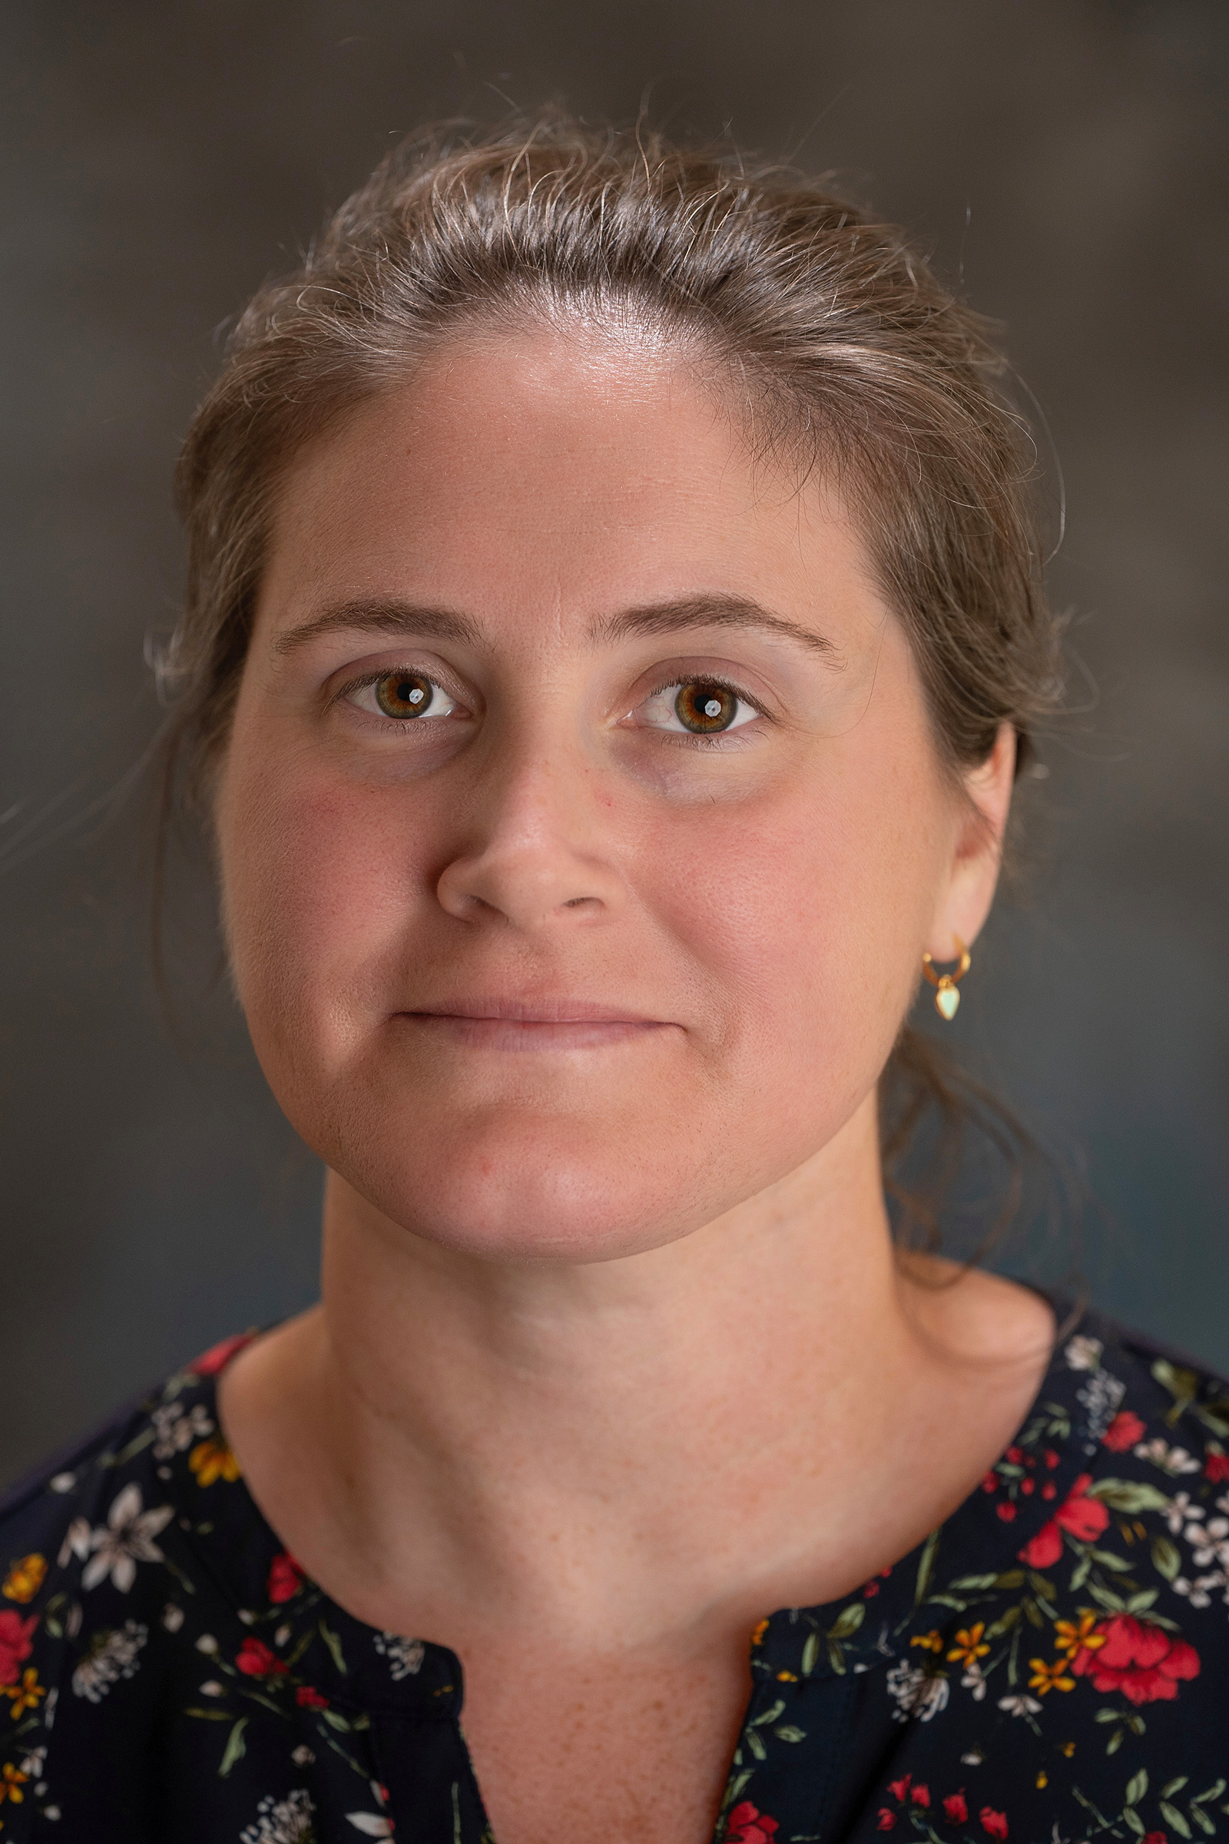**Heidi Semple** works with vascular and general surgery patients. She completed the master of science in nursing – family nurse practitioner program at Simmons College based in Boston. She grew up in Eugene, the daughter of an OR tech. “Medicine, particularly surgery, feels like home,” she says. “It’s the only career I’ve ever known. I feel I serve my community best by sharing skills and knowledge that I’m familiar with.”

**About PeaceHealth:** Based in Vancouver, Wash., PeaceHealth is a not-for-profit Catholic health system offering care to communities in Washington, Oregon and Alaska. In 1890, the Sisters of St. Joseph of Peace founded what has become PeaceHealth.

**PeaceHealth Sacred Heart Medical Center at RiverBend** is one of Oregon's busiest hospitals located in Springfield, Ore., 110 miles south of Portland. This 347-bed facility is one of the largest hospitals between Portland and San Francisco, serving as a Level II Trauma Center for an eight-county region. Key services for the not-for-profit hospital include cardiology and cardiovascular surgery, oncology, orthopedics, neonatal intensive care, neurosurgery and other specialized surgical services. Visit us online at [peacehealth.org](http://www.peacehealth.org/).

###