

November 17, 2023

For Immediate Release

Contact: Sherri Buri McDonald

Media relations

[sburimcdonald@peacehealth.org](mailto:sburimcdonald@peacehealth.org) or 541-520-8219

Meet the surgeons with PeaceHealth Surgical Specialties at Northwest Specialty Clinics

SPRINGFIELD, Ore. – PeaceHealth is pleased to welcome seven skilled and talented surgeons from Northwest Surgical Specialists to PeaceHealth Medical Group. This group is now officially PeaceHealth Surgical Specialties at Northwest Specialty Clinics. The new practice includes board-certified experts in general surgery, minimally invasive procedures, colorectal, foregut and other oncologic surgical care. They continue to be based at the Northwest Specialty Clinics building on the RiverBend campus (3355 RiverBend Drive, Suite 300). Phone is 541-222-8333.

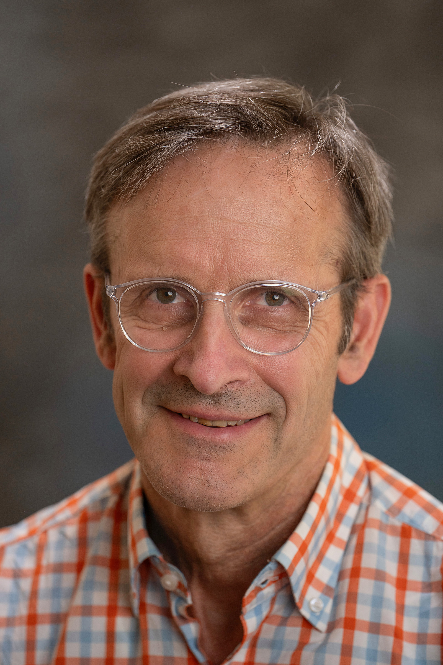**Dr. Thomas Bascom** has practiced general and vascular surgery in the Eugene-Springfield area since 1991. He earned his medical degree at the University of Washington in Seattle. He then completed his general surgery residency at the University of Wisconsin in Madison before receiving additional training in colon and rectal surgery at Gloucestershire Royal Hospital in Gloucester, England. Raised in Eugene, Dr. Bascom has deep roots in the community. His mother Ruth was Eugene's first woman mayor. His father John, a general surgeon, pioneered an operation for pilonidal disease that bears the Bascom name and brings to the practice patients and physicians from around the globe.

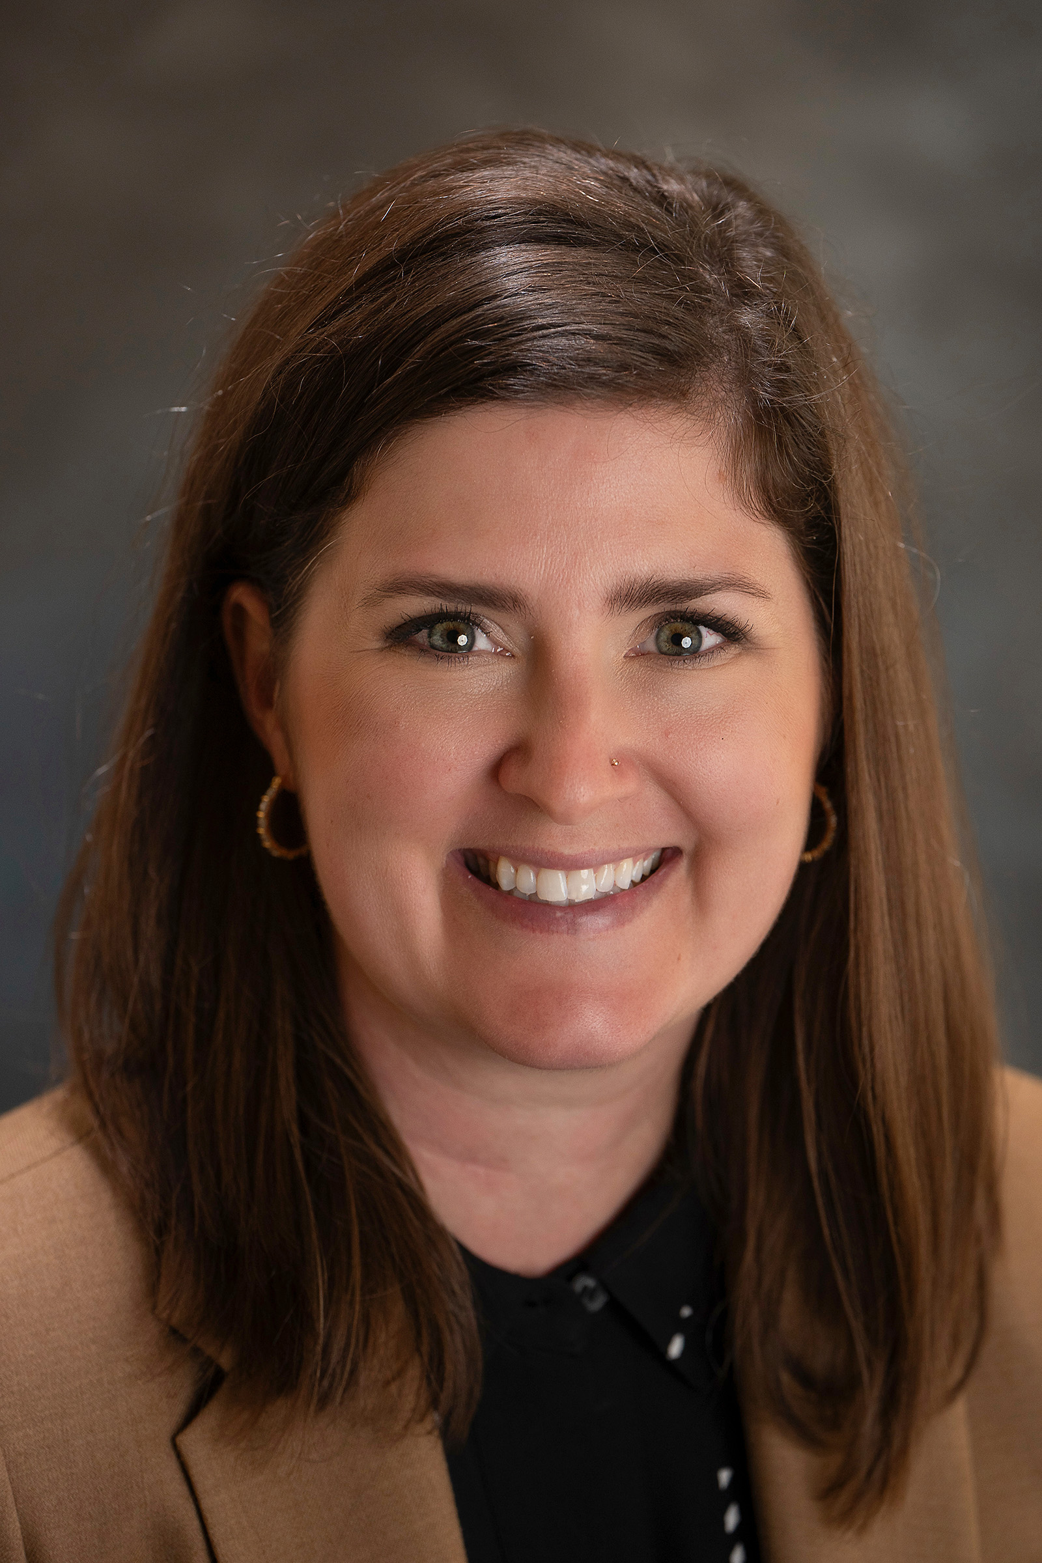**Dr. Katelyn Clark** is skilled in the breadth of general surgery from gallbladder and hernia to complex anti-reflux and colorectal procedures, all with a minimally invasive approach. She earned her medical degree and completed her surgical residency at Oregon Health & Science University in Portland. Born and raised in Eugene, Dr. Clark is a Marist High School graduate. Patients commend Dr. Clark for her technical skill as well as her compassion. "I chose medicine to help people," she says. "I chose surgery because it gave me the opportunity to help many people in a very tangible way, while also helping them through their experience."

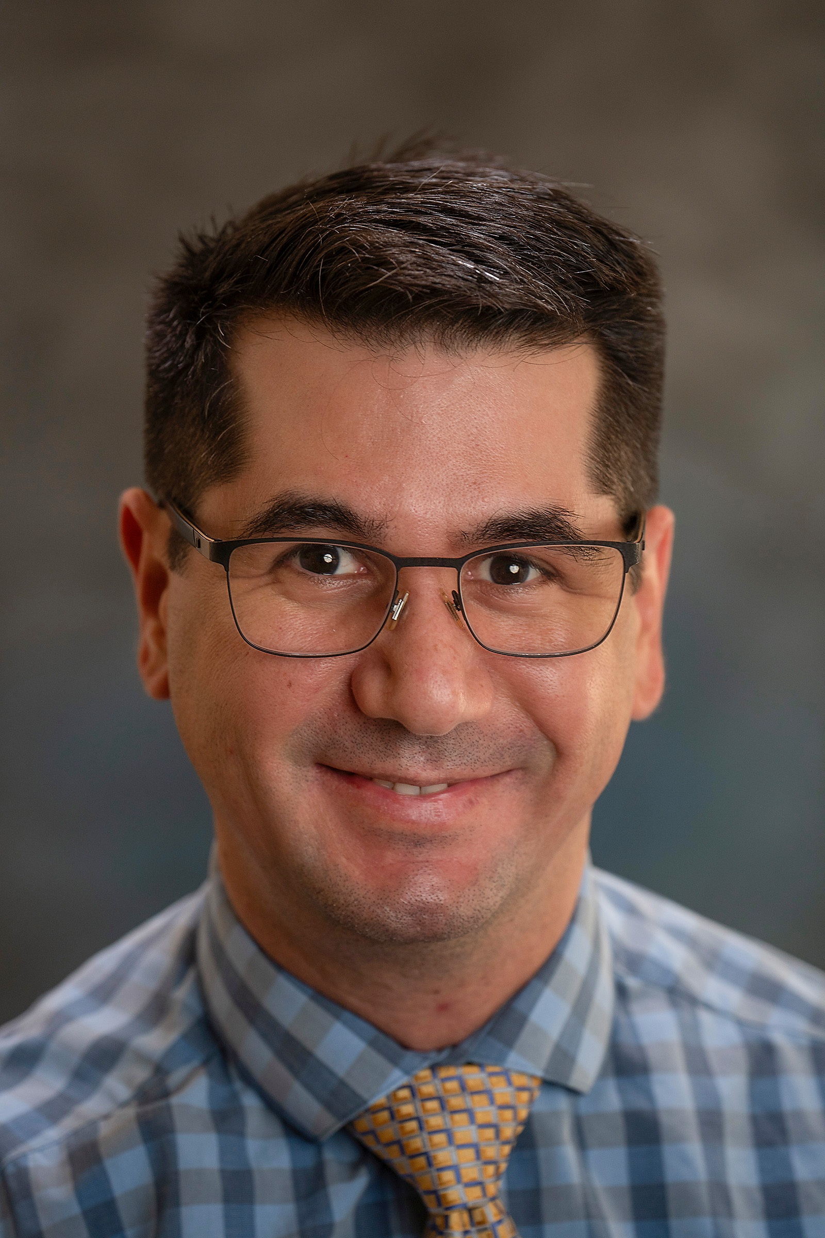**Dr. Daniel Cusati** treats a variety of conditions using the latest technology and techniques, including minimally invasive and laparoscopic surgery. He has special interest in pancreatic, liver and oncologic surgery, hernia repair and abdominal wall reconstruction. Dr. Cusati was born and raised in Venezuela and speaks Spanish and English. He earned his medical degree at Universidad Central de Venezuela – Escuela de Medicina Luis Razetti. Then he completed a general surgery residency at Mayo Clinic in Rochester, Minn., followed by surgical sub-specialty training and two fellowships in minimally invasive surgery and in hepato-pancreato-biliary (liver, pancreas, gallbladder and bile duct) surgery. He is dedicated to providing the highest level of surgical care: "I want patients to feel listened to, informed and confident about their decision and their plan for treatment."

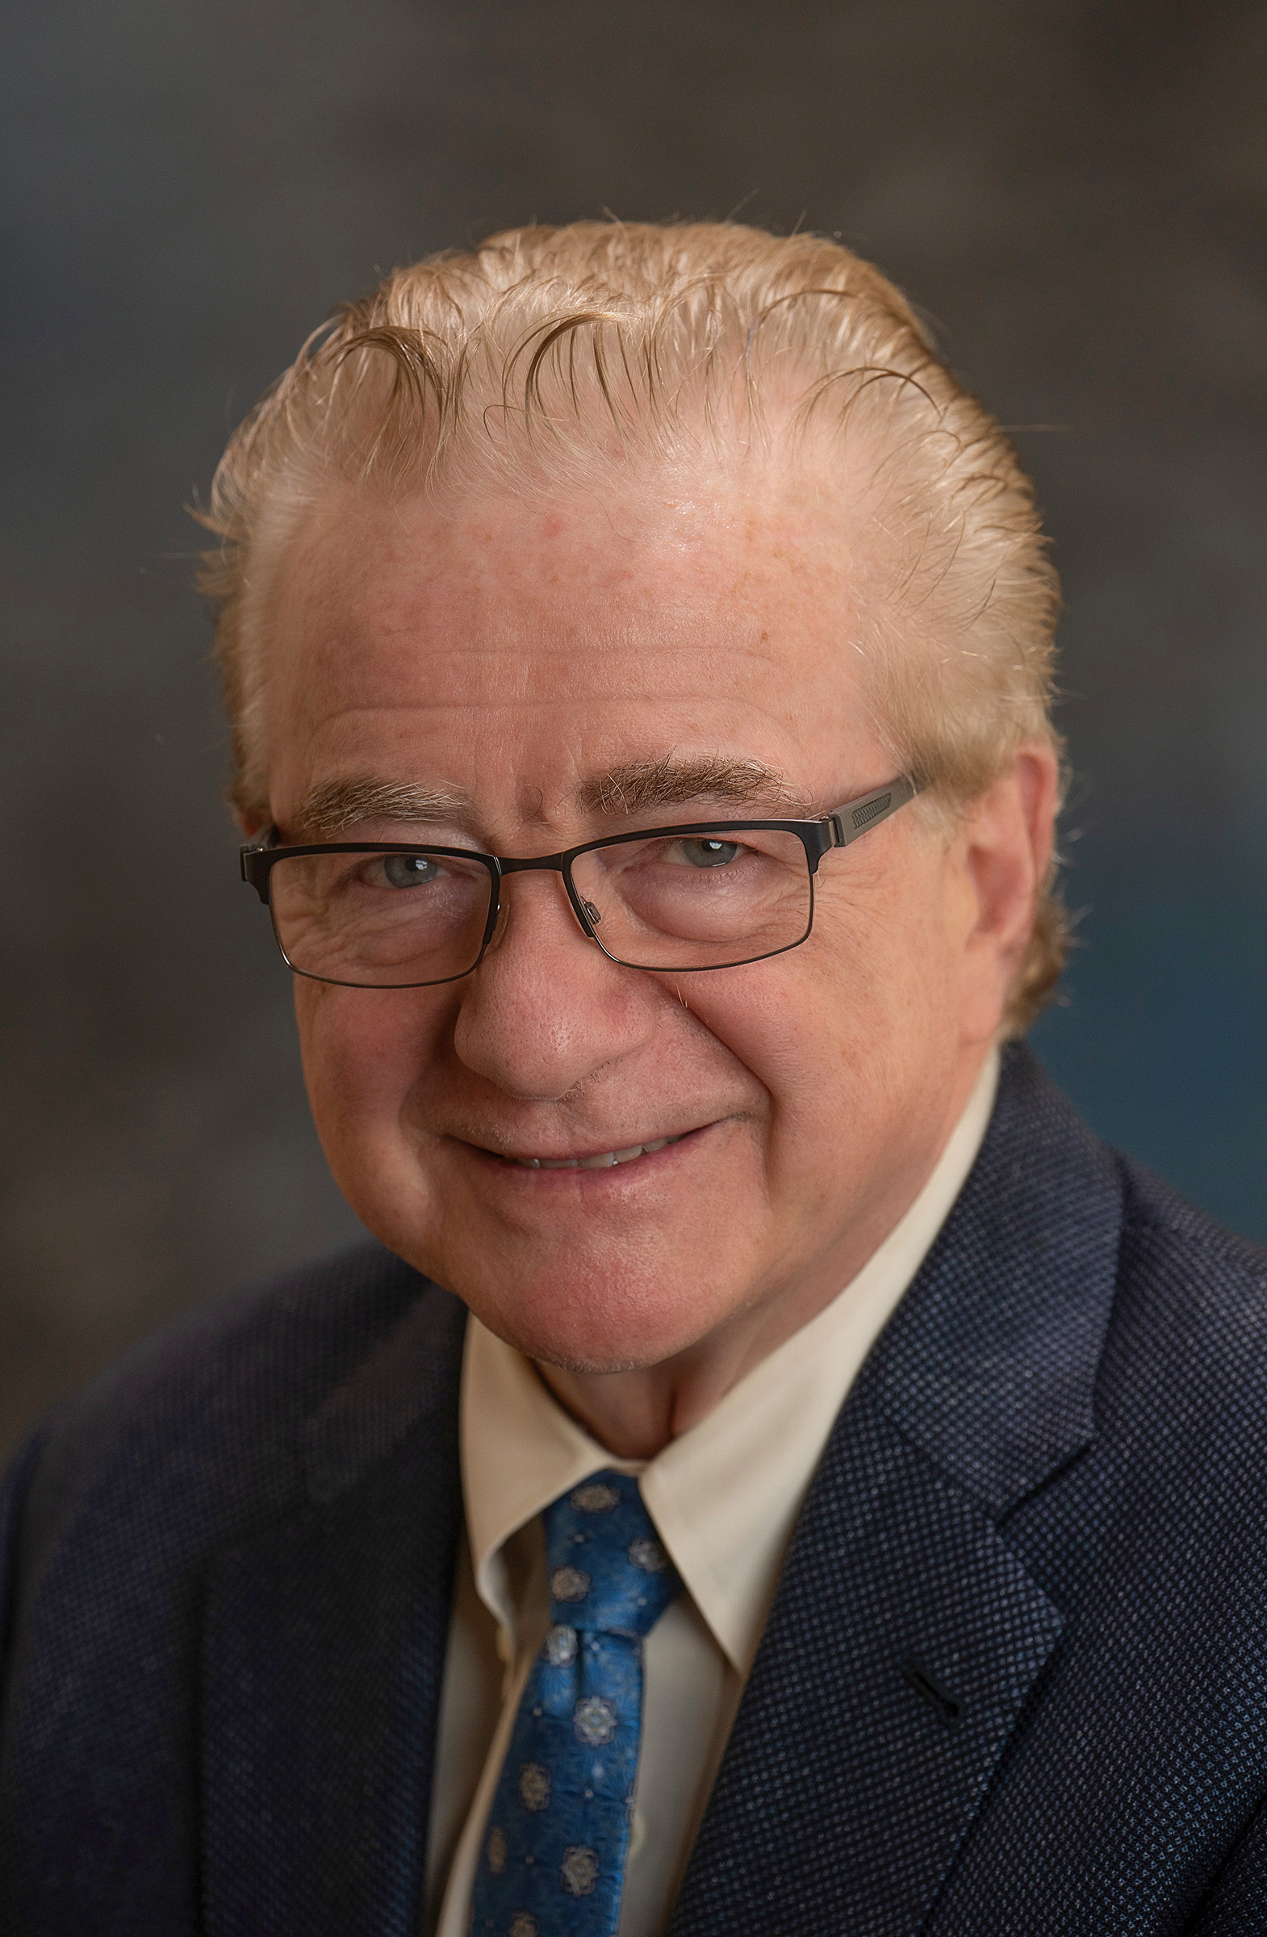**Dr. David DeHaas Jr.** has special interest and expertise in colorectal, esophageal, vascular and oncologic surgery. He earned his medical degree from Hahnemann University College of Medicine in Philadelphia. He completed his general surgery residency at the University of Wisconsin, in Madison, then received special training in colorectal, general and vascular surgery at Gloucestershire Royal Hospital in Gloucester, England. In addition to his surgical practice, he serves as the medical director of surgery and clinical course director for the medical student education program at PeaceHealth Sacred Heart Medical Center at RiverBend.

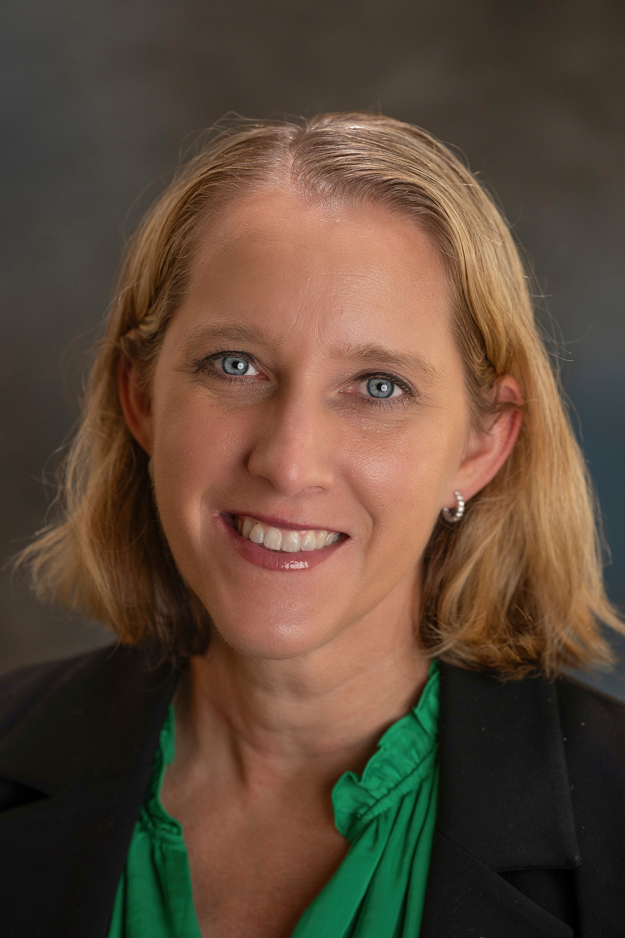

**Dr. Nichole Ingalls** is skilled in treating breast cancer and a range of other conditions including diseases of the gallbladder, colon and thyroid, and hernias. She earned her medical degree at Baylor College of Medicine in Houston. She completed her residency at Michigan State University in Grand Rapids and a trauma and critical care fellowship at the University of Cincinnati in Ohio. She was an active duty Air Force trauma surgeon at the University Medical Center in Las Vegas. In 2012, she served as the trauma director at Craig Joint Theater Hospital in Afghanistan. During her service, she was active in research and taught medical students, residents and fellows. Describing her approach to medicine, she says, "I develop deep relationships with my patients. They're very important to me and I take care of them like family members."

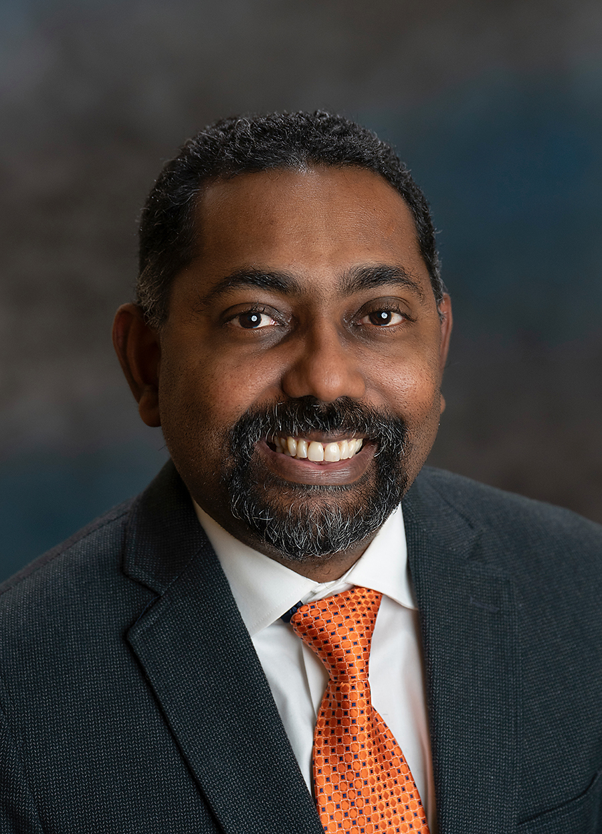**Dr. Kevin Modeste** treats a range of conditions using the latest robotic surgery technologies. He has expertise and training in skin cancers as well as benign (noncancerous) and malignant (cancerous) diseases of the GI tract. He was born and raised in the southern Caribbean islands of Trinidad and Tobago. He earned his MBBS (the British equivalent of the MD) at the University of the West Indies. He completed his general surgery residency at the University of Connecticut in Farmington and a surgical critical care fellowship at Hartford Hospital. He also has additional training for the detection and treatment of skin cancer from the University of Queensland in Brisbane, Australia. Dr. Modeste says when he meets a patient for the first time, he is interested both in the surgical problem and who they are as a person. "Undergoing surgery can be a stressful experience," he says. "I never want a patient or their family to feel they're on the journey alone."

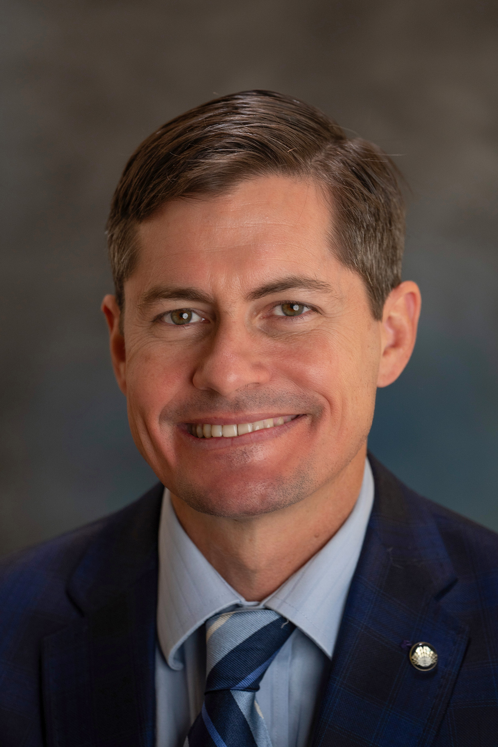**Diego Muilenburg, MD,** is a surgical oncologist who understands the unique challenges patients with cancer face. "I strive for the best approach for each patient, applying available technology and current guidelines for cancer care," he says. Dr. Muilenburg is experienced with robotic surgery and uses minimally invasive techniques whenever possible. He has a particular interest in robotic surgery for gastrointestinal cancers, including those of the esophagus and stomach, and the pancreas and rectum. He also treats breast cancer, soft tissue sarcomas and skin cancers. He earned his medical degree from Georgetown University School of Medicine in Wash., D.C. He completed his general surgery residency at the University of California Davis in Sacramento, and a clinical fellowship in complex general surgical oncology at the H. Lee Moffitt Cancer Center in Tampa, Fla.

**About PeaceHealth:** Based in Vancouver, Wash., PeaceHealth is a not-for-profit Catholic health system offering care to communities in Washington, Oregon and Alaska. In 1890, the Sisters of St. Joseph of Peace founded what has become PeaceHealth.

**PeaceHealth Sacred Heart Medical Center at RiverBend** is one of Oregon's busiest hospitals located in Springfield, Ore., 110 miles south of Portland. This 347-bed facility is one of the largest hospitals between Portland and San Francisco, serving as a Level II Trauma Center for an eight-county region. Key services for the not-for-profit hospital include cardiology and cardiovascular surgery, oncology, orthopedics, neonatal intensive care, neurosurgery and other specialized surgical services. Visit us online at [peacehealth.org](http://www.peacehealth.org/).

###