FOR IMMEDIATE RELEASE
Grants Pass & Josephine County Chamber of Commerce
www.grantspasschamber.org
RE: Concerts in the Park 2024
Contact: Christie Swafford (541) 226-3101
cswafford@grantspasschamber.org

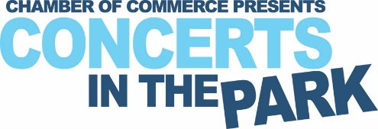

The Grants Pass & Josephine County Chamber of Commerce is currently accepting Band applications for the 2024 Concerts in the Park season. We are seeking bands that have a strong stage presence, showmanship and sets appropriate for the entire family. To ensure decorum and expand the opportunity, bands who have previously played at our venue must wait (3) calendar years to re-apply. Applications are due by January 22nd, 2024. BAND APPLICATION

We are looking for individuals or groups at each concert to sing the National Anthem. This is an esteemed volunteer opportunity. All applicants must be willing to audition for Chamber staff. Applications are due by February 23rd, 2024. ANTHEM APPLICATION

We would not be able to continue to offer this FREE gift to the community without the help of amazing partners and supporters. Concerts in the Park is a very popular family event which allows for prime marketing opportunities. We offer sponsorship levels to fit any budget. SPONSOR APPLICATION

For vendors, we have several options available: To ensure vendors are successful, we deter vendors from selling competing products and may request that you change or refrain from selling certain items. POWERED VENDOR APPLICATION NON-POWERED VENDOR APPLICATION

For questions contact Christie Swafford for more information, 541-226-3101 or email cswafford@grantspasschamber.org

