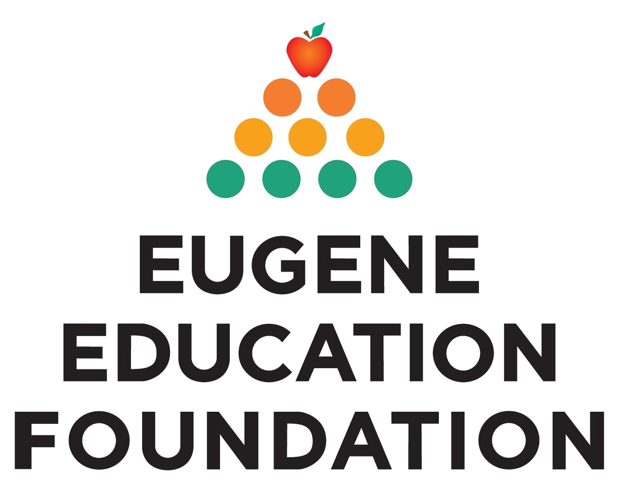

FOR IMMEDIATE RELEASE
Contact: Nancy Buffum, Executive Director,
eef@eeflane.org, 541-790-7744

MOVING FORWARD TOGETHER: EEF AND THE EUGENE COMMUNITY SUPPORT STUDENTS IN SCHOOL DISTRICT 4J

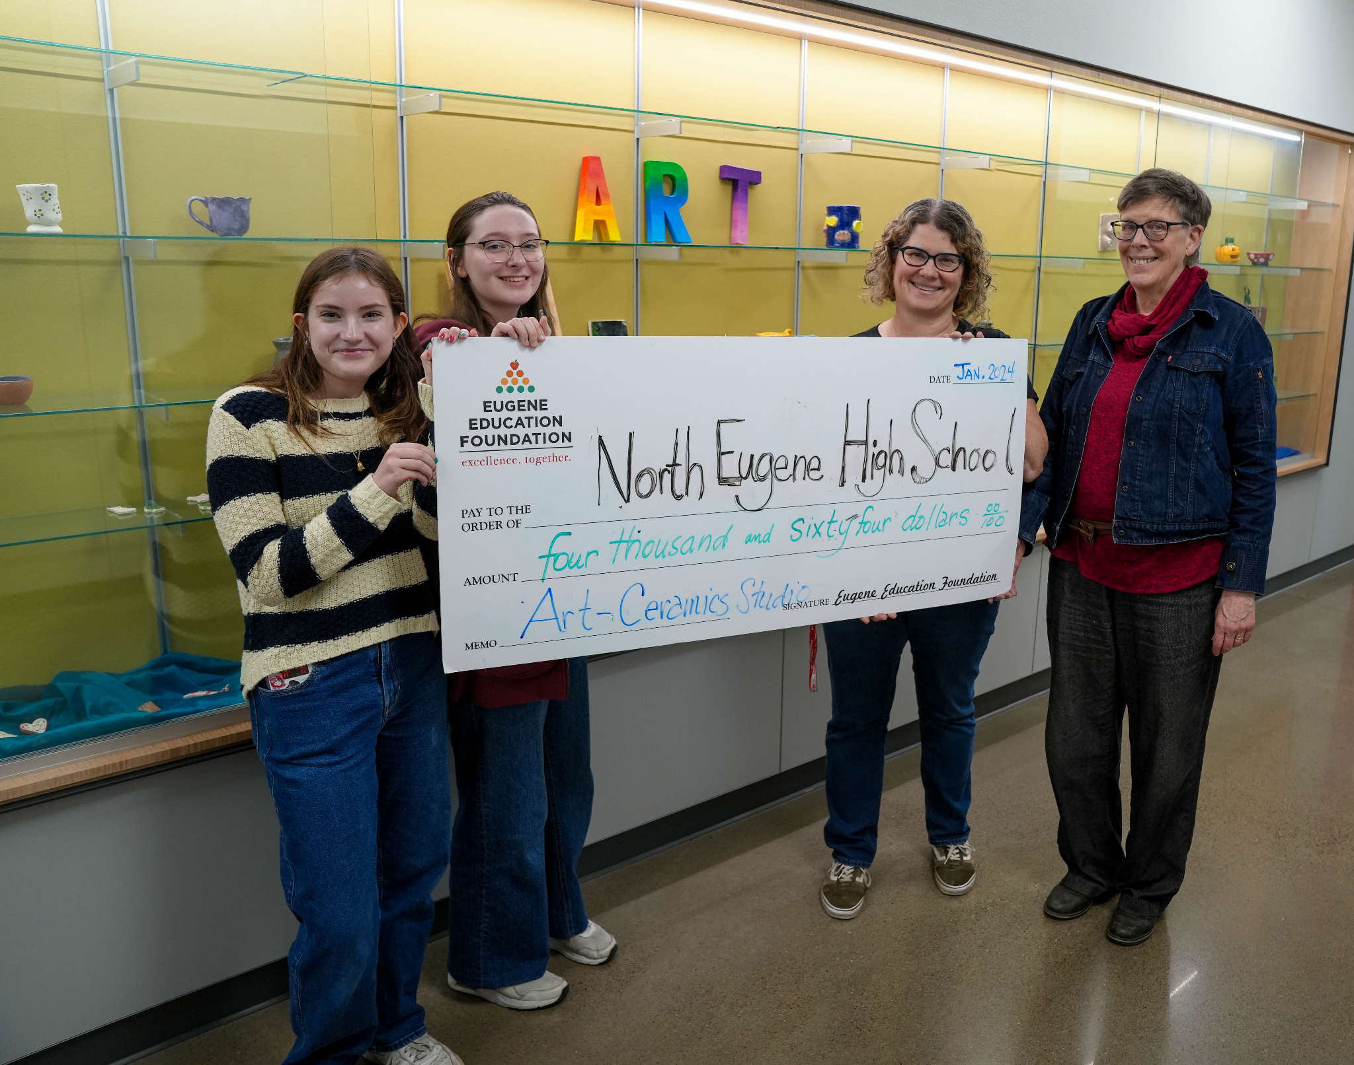
Image: North Eugene High School art students and their teacher receive a big check

“I don’t know what we’d do without the Eugene Education Foundation!” says Amy Samson, art teacher at North Eugene High School. On the winter’s day between first and second semester, Ms. Samson was in her classroom when EEF showed up with a big check. Several of her students joined their teacher at this favorite hangout spot, the art room, even though they had the day off school.

Ms. Samson’s art class received one of 55 grants from the Eugene Education Foundation toEugene School District 4J for school- and district-level projects for 2023-24, totaling $148,171. Generous community donors and partners contribute to EEF, and EEF transforms this community generosity into initiatives that further educational excellence and opportunities for students in Eugene School District 4J. Since 1993, EEF has invested $3.6 million to further educational excellence and open up opportunities for all the students in 4J

EEF Grantee Spotlight: Art as a Career Path
North Eugene High School has a thriving arts community, according to art teacher Amy Samson. In 2022, EEF awarded NEHS a grant for “Art as A Superpower,” providing the high schoolers with quality art supplies so they could achieve success in their projects. Ms, Samson and her students joined the community last October’s “5K for 4J/Fun Run Rolle & Stroll” in Alton Baker Park and helped younger children make seasonal crafts in the picnic area.

Then Ms. Samson dreamed big. This year, she wanted to launch a project that would encompass leadership development as well as artistic skill. Her students would learn entrepreneurial skills, show their artwork, and see a way that their creativity could provide a pathway to their future as adult artists.

EEF awarded NEHS a 2023-24 grant for “Reinventing the Guild Model for Ceramics Studio”. The $4,064 grant will transform the ceramics program from a series of classes to a guild model, where students move from the apprentice to the master level. Students learn and practice ceramics skills, master their craft, and also develop business and mentoring skills. Advanced students will mentor students who are new to the ceramics program. The Guild experience includes planning and participating in a Guild Night to exhibit and sell artwork. Ms. Samson envisions that the Ceramics Guild will also serve those in the community who may engage the Guild in producing custom work.

Best of all, Guild Night is designed to help fund the ceramics guild program going forward. “My hope is that the guild will become self-sustaining, thus helping to fill the deficit in funding in future years for visual arts at North Eugene High School, ” says Samson.

Expanding Enrichment, Ready-to-Learn and Career Pathways for All 4J students. In the 2020 COVID-19 crisis, 4J educators and parents scrambled to address multiple issues beyond the challenge of engaging children in distance learning.The pandemic school resources. School closure, economic disruption and social isolation exacerbated the pressures on families with school age children.

EEF pivoted to respond to the urgent needs of 4J students and their families when schools closed suddenly. EEF and community supporters stepped forward with emergency supplies for 4J families including food, household necessities, Wifi hotspots, and other technology.

Educators in 4J and parents tell us that students are still recovering from their past separation from school. Children need their basic needs met to be ready to learn. Health, safety, and culturally responsive programming are all crucial to equitable access to opportunities.
EEF offers grants for social and emotional support, including mental health services; the priority of early literacy, enrichment (the arts, STEM, experiential learning such as field trips and cultural events) and learning pathways. EEF grants like the Ceramics Guild at NEHS can be the motivator for attending school, a doorway to discovery of a passion that can lead to future opportunities.

EEF invites contributions and partnerships with businesses and community members to fund educator initiated projects for the next round of grants to 4J. EEF’s biggest fundraiser of the year is the EEF Moving Forward Together Annual Dinner and Auction, on March 21, 2024 at UO Ford Alumni Center. Community members may purchase tickets to attend, help underwrite the event, or make a donation at eeflane.org,
For a full list of 2023-24 grantees or to make a donation to support EEF, visit the website at eeflane.org. or contact 514/790-7744 or eef@eeflane.org. EEF corporate partners are listed on the event page. EEF Annual Grants applications for 2024-25 will be available April1.
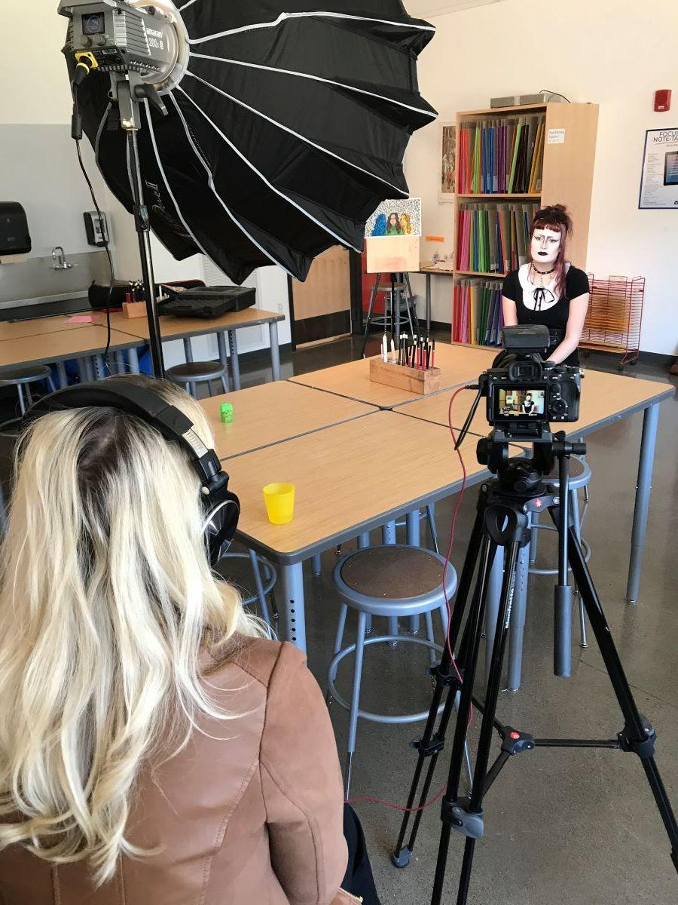
image description: NEHS art student is interviewed to help promote the EEF fundraiser on March 21
#####

